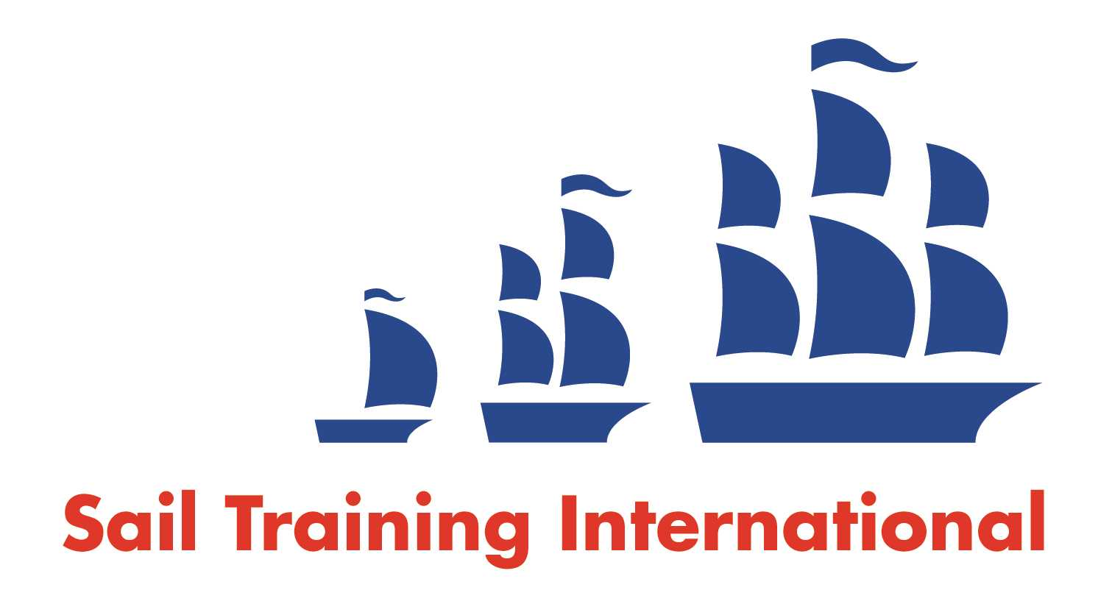
Sail Training International Paid/Volunteer Positions Submission Form

Editorial Policy

- This listing facility is free of charge but will only be accepted from sail training organisations and vessel operators that are members of their national sail training organisation or the Sail Training International Class A Tall Ships Forum.

- STI reserves the right not to publish a listing for any reason whatsoever.

- After completing the form, email to STI (office@sailtraininginternational.org) with copy to your National Sail Training Organisation for editorial review and approval prior to publishing on site.

Date of Posting
Name of Vessel | Swan LK243
Organisation Recruiting | The Swan Trust SCIO
Name of Position | Seasonal Skipper
Location of Position | Lerwick based, Sailing around Shetland, NE Scotland and Faroe during summer 2027.
Position is | Full Time |  | Seasonal | X
Remuneration | Paid | £30,000 to £35,000 Pro Rata (before deductions); depending on experience
Description of Position | Date: 1st April to 30th September – may be available on a job share basis  Skipper to join established Mate and volunteer crew on board 20m Gaff Ketch Fifie, Swan LK243. To oversee safety and operation of vessel while delivering quality sail training skills to passengers of all ages.  The boat is predominantly used as a sail training vessel with some private charter and public trips.  Swan named as National Historic Ships Flagship of the Year 2023 and ASTO Sail Training Vessel of the Year 2024.  Skipper requirements:  The following qualifications and certifications are required as a minimum for this role:  - RYA Yachtmaster Offshore Commercially Endorsed Certificate, or MCA accepted equivalent or higher qualification  - Radio Operator’s certificate, suitable for the radio equipment on board  - Medical Fitness Certificate, ENG1  Basic Sea Survival Course.  - First Aid Training. STCW Proficiency in Medical Care Certificate, or its predecessor, STCW Ship’s Captain’s Medical Certificate.  - Radar training  - MCA approved fire fighting course  - Elementary Food Hygiene Level 2  - Approved diesel engine course (or certified engineer)  Stability Guidance Booklet Familiarisation
Person to Contact
Organisation’s website: | www.swantrust.com
Email | info@swantrust.com
Telephone
Fax
Closing Date for applications | 13/11/2026

