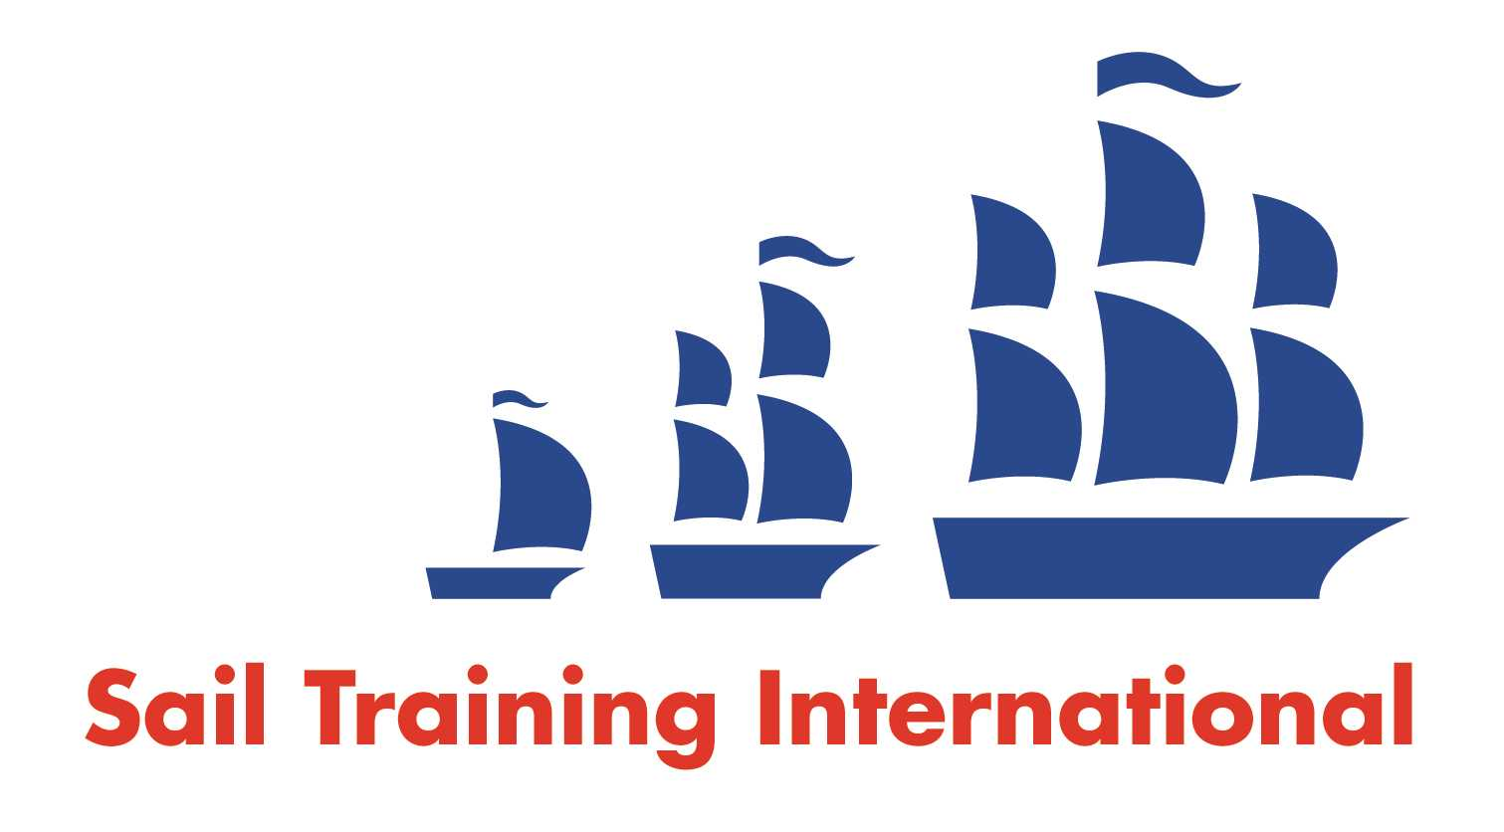
Sail Training International Positions Sought Submission Form

Editorial Policy

- This listing facility is open to any vessel operator or organisation involved in sail training.

- STI reserves the right not to publish a listing for any reason whatsoever.

- After completing the form, email to STI (office@sailtraininginternational.org) for editorial review prior to publishing on site. You can expect your advertisement to appear within 2-3 business days.

- Your listing will be automatically removed after three months unless you indicate an earlier date. To retain a listing beyond three months, please notify STI before the end of the three month period.

Date of Posting | 4 abril 2026
Name | ROGER WILLIAM MERINO ABRIOJO
Position Sought | TECNICO COMUNICADOR AUDIOVISUAL
Location preference | CAMAROGRAFO/ EDITOR
Full Time / Seasonal  (delete as appropriate) x |  | Paid / Voluntary  (delete as appropriate)
Description of Position Sought  (max 100 words) | Técnico en comunicación audiovisual con mas de 20 años de experiencia en la armada del Perú, editor de video, manejo de plataformas para edición, piloto de drone, con muchas ganas de sumar mi experiencia marinera en producciones de competencia.  En el mar y haber participado en la regata the tall ships races 2025 abordo del bap Unión
Qualifications
Email | Rogermerino01@yahoo.es
Telephone | 51-983435043

