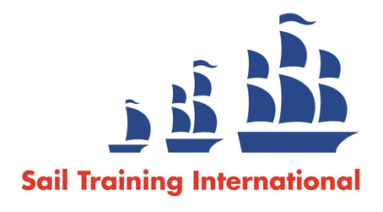

Sail Training International Positions Sought Submission Form

Editorial Policy

- This listing facility is open to any vessel operator or organisation involved in sail training.

- STI reserves the right not to publish a listing for any reason whatsoever.

- After completing the form, email to STI (office@sailtraininginternational.org) for editorial review prior to publishing on site. You can expect your advertisement to appear within 2-3 business days.

- Your listing will be automatically removed after three months unless you indicate an earlier date. To retain a listing beyond three months, please notify STI before the end of the three month period.

Date of Posting | 08/04/2026
Name | Rodrigo Maltempi Mendes
Position Sought | Deckhand
Location preference | Anywhere, Worldwide
Full Time / Seasonal  Both |  | Paid / Voluntary  I am open for both, but Paid would be great (even if it is only my flights)
Description of Position Sought  (max 100 words) | Motivated crew member seeking a position in Tall Ships Racing, with a strong passion for naval history and traditional sailing. Deeply inspired by classic seamanship and the heritage of tall ships, combined with a genuine interest in multicultural environments and international crews. Former exchange student, fluent in English, and comfortable adapting to diverse cultures. Extensive hands-on experience with manual work, including maintenance, painting, and general deck tasks. Hardworking, disciplined, and ready for physically demanding conditions at sea. Fully committed to learning, contributing to the crew, and building a long-term career in offshore sailing and yacht deliveries.
Qualifications | IYT Deckhand, Smallpowerboat and RIB Master.
Email | digomendes.m@gmail.com
Telephone | +55 19 997752424

