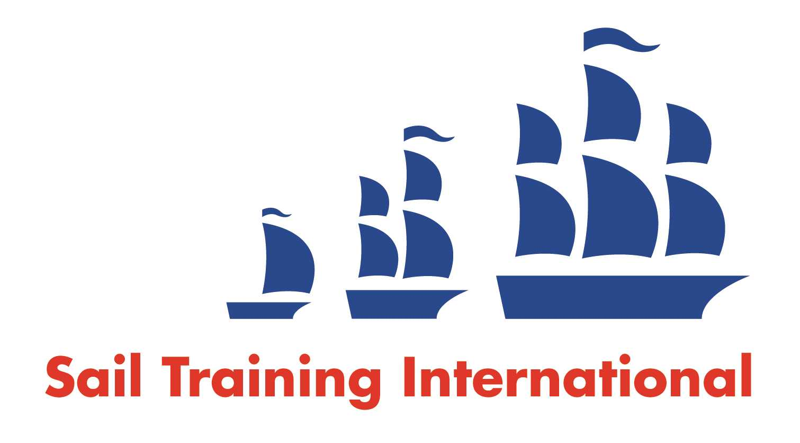
Sail Training International Paid/Volunteer Positions Submission Form

Editorial Policy

- This listing facility is free of charge but will only be accepted from sail training organisations and vessel operators that are members of their national sail training organisation or the Sail Training International Class A Tall Ships Forum.

- STI reserves the right not to publish a listing for any reason whatsoever.

- After completing the form, email to STI (office@sailtraininginternational.org) with copy to your National Sail Training Organisation for editorial review and approval prior to publishing on site.

Date of Posting | Oktober 2025
Name of Vessel | Eye of the Wind
Organisation Recruiting | FORUM train & sail GmbH, Germany
Name of Position | Chief Mate (m / f / d)
Location of Position | Worldwide
Position is | Full Time | x | Seasonal
Remuneration | Paid | € - TBD
Description of Position | Your tasks  We are seeking an ocean going, 200 GT or above qualified mate, preferably with a background in sail training. Familiarity with traditional ships, including extensive square rig experience, is essential. Applicants should be energetic, and able to fit comfortably into a young, international team of people with varying levels of experience.  Your duties will include watchkeeping, maintenance of safety and navigation equipment, medical equipment and active participation on deck in all activities and manoeuvres related to the operation of the ship. You will also be responsible for coordinating the operation and maintenance of all rigging components and general ship maintenance tasks, as well as looking after a maximum of 12 guests and providing guidance and support for interior maintenance.  You will work in an on/off system of approx. three months on board / three months off (1:1 rotation).  Your requirements / your profile  You have a valid STCW Basic Safety Certificate of Competency, a valid ENG 1 seafarer medical fitness certificate and a qualification for ocean-going vessels from 200 GT. You act responsibly, are service-orientated and have a friendly tone of voice. You also have the necessary physical requirements for working on board a seagoing vessel. You can confidently apply your extensive practical experience on rigged sailing school ships and you can competently pass on your specialist knowledge to our trainees. Good English - and preferably German - language skills are required for communicating with staff and guests.  The Eye of the Wind is a charter ship with a special sailing area and an international crew of 10. A prerequisite for permanent employment is your willingness to familiarise yourself with your workplace and our crew members during a trial week on board.  Have we piqued your interest?  Then we look forward to receiving your application with CV and proof of qualifications to info@eyeofthewind.net
Person to Contact | Julia Nieborowsky
Organisation’s website: | www.eyeofthewind.net
Email | info@eyeofthewind.net
Telephone | +49 8233 / 381 - 227
Fax | -
Closing Date for applications | We look forward to receiving your unsolicited application.

