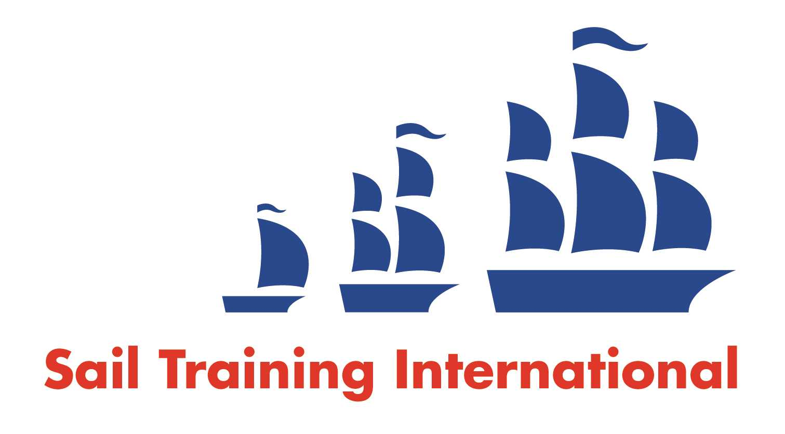
Sail Training International Paid/Volunteer Positions Submission Form

Editorial Policy

- This listing facility is free of charge but will only be accepted from sail training organisations and vessel operators that are members of their national sail training organisation or the Sail Training International Class A Tall Ships Forum.

- STI reserves the right not to publish a listing for any reason whatsoever.

- After completing the form, email to STI (office@sailtraininginternational.org) with copy to your National Sail Training Organisation for editorial review and approval prior to publishing on site.

Date of Posting | 02/09/2025
Name of Vessel | Various
Organisation Recruiting | Marine Society and Sea Cadets
Name of Position | Offshore Maintenance Manager
Location of Position | Gosport PO12
Position is | Full Time | x | Seasonal
Remuneration | Paid  (delete as appropriate) | £36,00-£39,000  (delete as appropriate)
Description of Position | The Offshore Maintenance Manager will have a key role in delivering the capability and availability of MSSC’s offshore vessels to provide sea-going experience for cadets and in ensuring the safety for all personnel on board. The main purpose of the role is to provide support with the engineering management and maintenance of MSSC’s offshore vessels
Person to Contact | Danielle Honey
Organisation’s website: | https://apply.workable.com/mssc/j/1FDBD98CE8/
Email | recruitment@ms-sc.org
Telephone | 02076547000
Fax
Closing Date for applications | 07/10/2025

