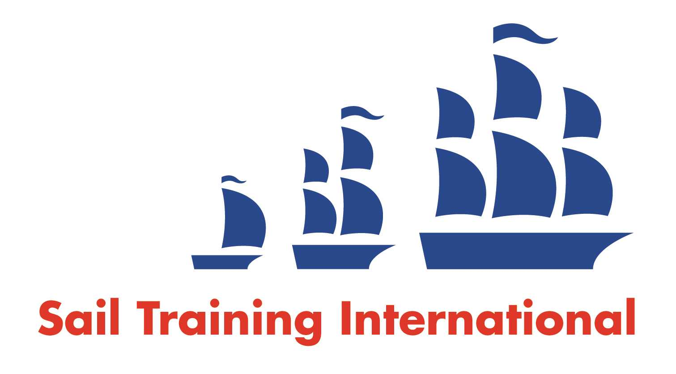
Sail Training International Paid/Volunteer Positions Submission Form

Editorial Policy

- This listing facility is free of charge but will only be accepted from sail training organisations and vessel operators that are members of their national sail training organisation or the Sail Training International Class A Tall Ships Forum.

- STI reserves the right not to publish a listing for any reason whatsoever.

- After completing the form, email to STI (office@sailtraininginternational.org) with copy to your National Sail Training Organisation for editorial review and approval prior to publishing on site.

Date of Posting | 08/09/2025
Name of Vessel
Organisation Recruiting | Gordonstoun
Name of Position | Bosun
Location of Position | Elgin, Scotland
Position is | - Full Time
Remuneration | Paid | £25,976.00 per annum
Description of Position | Situated on the beautiful Moray Coast in the North of Scotland, Gordonstoun is widely recognised as the world leader in character education. We have a co-educational community of over 500 students aged from 6-18, who are predominantly full boarding and are drawn from over 40 countries.  The Gordonstoun Sail Training Department are recruiting for a permanent post of Bosun/Relief First Mate at the end of the 2025 sailing season. This is a great opportunity to become a member of the Gordonstoun staff with a generous salary and benefit package that includes accommodation and meals. Candidates must have a commercially endorsed YM Coastal Certificate of Competence or above and a current ENG1 Medical Fitness Certificate, as per maritime regulations. Please note a proven track record in Sail Training in positions of responsibility on sail training vessels is essential for this post.  Gordonstoun is striving to build a team that is truly inclusive. We welcome applications from marginalised and under-represented groups.
Person to Contact
Organisation’s website: | Gordonstoun
Email | recruitment@gordonstoun.org.uk
Telephone | 01343 837806
Fax
Closing Date for applications | 22/09/2025

