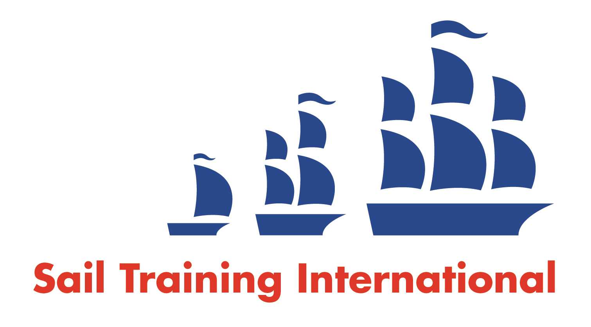
Sail Training International Paid/Volunteer Positions Submission Form

Editorial Policy

- This listing facility is free of charge but will only be accepted from sail training organisations and vessel operators that are members of their national sail training organisation or the Sail Training International Class A Tall Ships Forum.

- STI reserves the right not to publish a listing for any reason whatsoever.

- After completing the form, email to STI (office@sailtraininginternational.org) with copy to your National Sail Training Organisation for editorial review and approval prior to publishing on site.

Date of Posting | August 12, 2025
Name of Vessel | Pacific Grace and Pacific Swift
Organisation Recruiting | S.A.L.T.S. (Sail and Life Training Society)
Name of Position | Tall Ship Crew Member
Location of Position | Victoria, BC, Canada
Position is | Full Time | X | Seasonal
Remuneration | Paid | $40-104K
Description of Position | Sail on a Tall Ship for a Living!  Do you have a passion for adventure, leadership, and youth mentorship? We’re looking for crew to invest in the lives of young people through sail training and shipboard community on board SALTS’ tall ships. We are accepting applications for paid crew positions - previous sailing experience not required as training is provided!  SALTS is an independent Christian-based registered charity located in Victoria, BC. We seek to create an environment that is caring and respectful, where young people from all walks of life are encouraged, inspired, and heard. If you are passionate about supporting our mission and values, we want to hear from you! SALTS operates two schooners based out of Victoria BC, and each year 1700 young people participate in our program as trainees, on trips which are between 4 and 10 days long in coastal BC waters. Annual crew salaries range from $40K-$104K. Employment is typically full-time, year-round, but we also have need for some part-time crew positions if that is preferred.  For more details and to apply, visit https://salts.applytojobs.ca/
Person to Contact | Please apply online at salts.ca/careers
Organisation’s website: | www.salts.ca
Email | info@salts.ca
Telephone | + 1-888-383-6811
Fax
Closing Date for applications | Open until a suitable candidate is found

