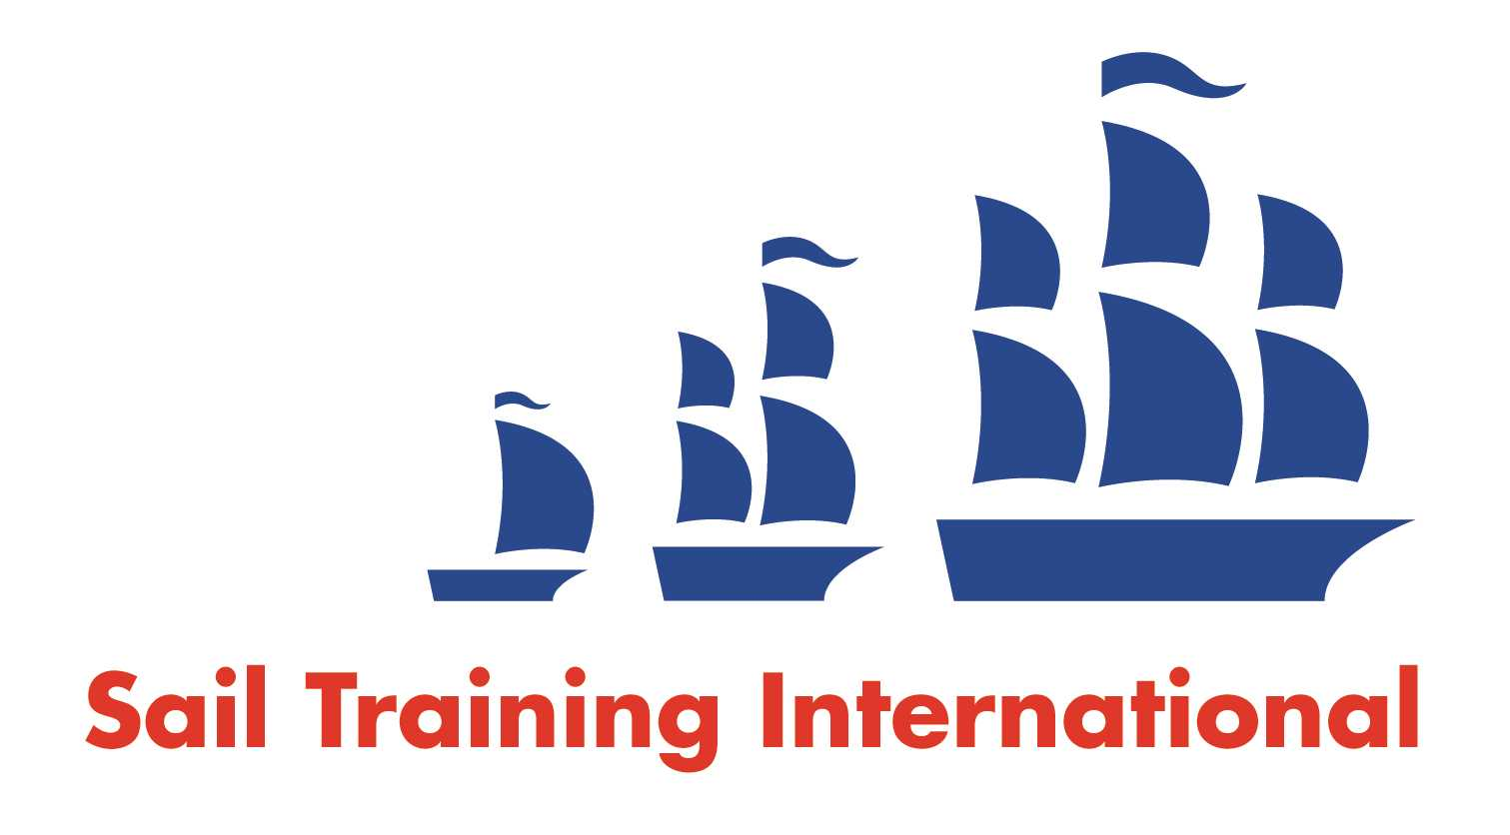
Sail Training International Positions Sought Submission Form

Editorial Policy

- This listing facility is open to any vessel operator or organisation involved in sail training.
- STI reserves the right not to publish a listing for any reason whatsoever.
- After completing the form, email to STI (office@sailtraininginternational.org) for editorial review prior to publishing on site. You can expect your advertisement to appear within 2-3 business days.
- Your listing will be automatically removed after three months unless you indicate an earlier date. To retain a listing beyond three months, please notify STI before the end of the three month period.

Date of Posting | 17-08-2025
Name | Connor Teskey
Position Sought | Captain, Mate, Watch Leader, Engineer
Location preference | Worldwide
Full Time / Seasonal |  | Paid
Description of Position Sought  (max 100 words) | Adventurous sailor seeking Captain, Mate, or Watch Leader roles aboard tall ships worldwide. My background includes square-rig experience as a watch officer and instructor with youth sail training programs, along with Atlantic crossings and varied offshore passages. I thrive on the challenge of ocean voyages and the unique teamwork of life under sail. Passionate about traditional seamanship and mentorship, I bring strong safety training steady leadership, and a love of inspiring crews while keeping the spirit of tall ship sailing alive.
Qualifications | - RYA Yachtmaster Offshore Sail (CE)  - AEC1 - MCA  - STCW Advanced Marine First Aid  - STCW Basic Safety  - STCW Proficiency in Survival Craft  - STCW Advanced Fire Fighting  - Professional Practices and Responsibilities  - Restricted Operator Certificate - Maritime Commercial  - Power Boat Level 2  - Marine Medical  - Simulated Electronic Navigation – limited (Radar)
Email | Connor.w.Teskey@gmail.com
Telephone | +1 519 531 0322

