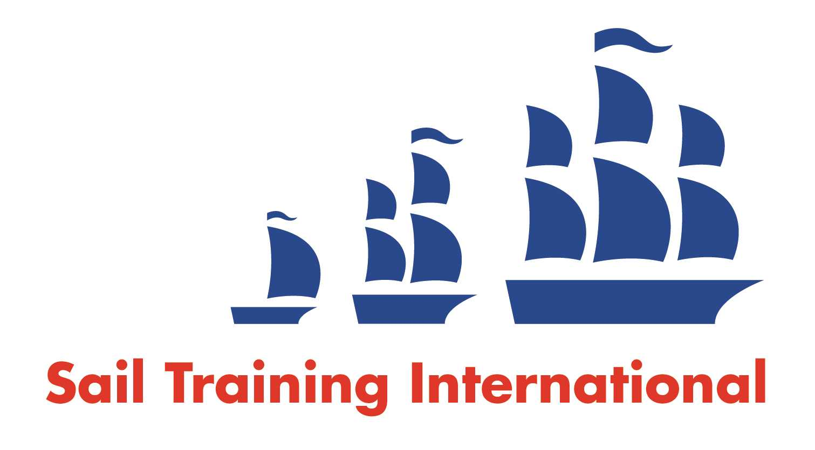
Sail Training International Paid/Volunteer Positions Submission Form

Editorial Policy

- This listing facility is free of charge but will only be accepted from sail training organisations and vessel operators that are members of their national sail training organisation or the Sail Training International Class A Tall Ships Forum.

- STI reserves the right not to publish a listing for any reason whatsoever.

- After completing the form, email to STI (office@sailtraininginternational.org) with copy to your National Sail Training Organisation for editorial review and approval prior to publishing on site.

Date of Posting | 10th July 2025
Name of Vessel | Prolific
Organisation Recruiting | Ocean Youth Trust South
Name of Position | Bookings Administrator
Location of Position | Southampton
Position is | Full Time |  | Part-time | ✓
Remuneration | Paid/Voluntary  (delete as appropriate) | €/$/ In the range £23,810 - £25,000 Pro rata
Description of Position | Ocean Youth Trust South is recruiting a Bookings Administrator to join our industry leading team.  The successful candidate will be an experienced administrator, with an effective track record of working in a high performing and professional setting, able to take responsibility for day-to-day business routines while supporting the rest of the staff team in taking the charity forward and maintaining our place as one of the UK’s leading sail training charities.  Full details and job description here: https://www.oytsouth.org/wp-content/uploads/2025/07/OYT_South_Bookings_Administrator_2025.pdf.
Person to Contact | Lynne Robbins
Organisation’s website: | www.oytsouth.org
Email | lynnerobbins@oytsouth.org
Telephone | 02392 602278
Closing Date for applications | 4th August 2025

