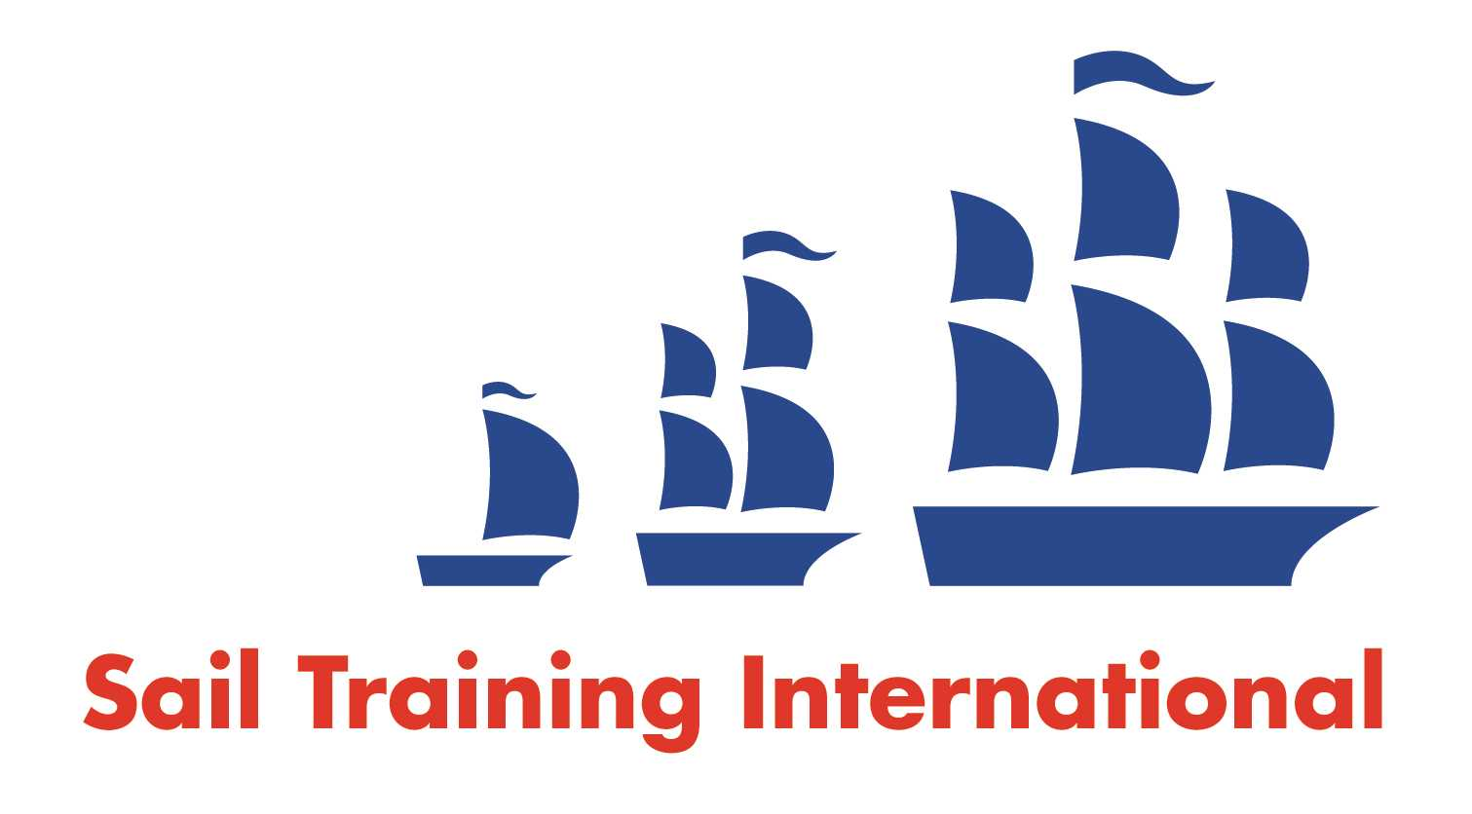
Sail Training International Paid/Volunteer Positions Submission Form

Editorial Policy

- This listing facility is free of charge but will only be accepted from sail training organisations and vessel operators that are members of their national sail training organisation or the Sail Training International Class A Tall Ships Forum.

- STI reserves the right not to publish a listing for any reason whatsoever.

- After completing the form, email to STI (office@sailtraininginternational.org) with copy to your National Sail Training Organisation for editorial review and approval prior to publishing on site.

Date of Posting | 13/06/2025
Name of Vessel | Sea Cadets Crosby Boat Station
Organisation Recruiting | Marine Society and Sea Cadets
Name of Position | Boat Station Manager - Crosby
Location of Position | Crosby Lakeside Adventure Centre, Waterloo, L22 1RR
Position is | Full Time | X | Seasonal
Remuneration | Paid | £37,000 gross per annum
Description of Position | We are currently looking for a Boat Station Manager to join our team.  The manager is instrumental in facilitating and delivering life changing, positive on the water experiences for young people. As an expert practitioner, they will provide leadership, development and mentoring to their team of instructors. The post will require strong organisational skills.  The Manager is an employee of the Marine Society & Sea Cadets based at our Crosby Boat Station. The post holder is required to hold and maintain the following qualifications as a condition of employment: RYA Senior Dinghy Instructor and RYA Powerboat Instructor.  The primary purpose of the role is to manage a water-sports training facility in the Liverpool area for all Sea Cadet Units and other affiliates to the Boat Station.
Person to Contact | Tony Elgar
Organisation’s website: | Boat Station Manager - Crosby - MSSC
Email | aelgar@ms-sc.org
Telephone
Fax
Closing Date for applications | 11/07/2025

