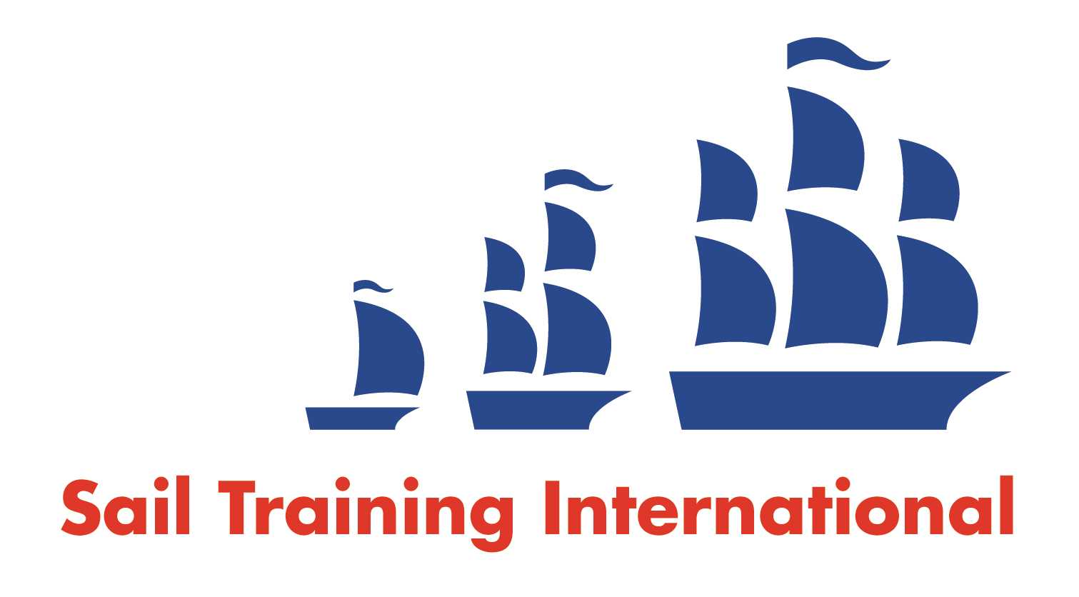
Sail Training International Paid/Volunteer Positions Submission Form

Editorial Policy

- This listing facility is free of charge but will only be accepted from sail training organisations and vessel operators that are members of their national sail training organisation or the Sail Training International Class A Tall Ships Forum.

- STI reserves the right not to publish a listing for any reason whatsoever.

- After completing the form, email to STI (office@sailtraininginternational.org) with copy to your National Sail Training Organisation for editorial review and approval prior to publishing on site.

Date of Posting | 02/05/2025
Name of Vessel | Sea Cadets Midlands Boat Station
Organisation Recruiting | Marine Society and Sea Cadets
Name of Position | Outdoor Activity Instructor Apprentice
Location of Position | Birmingham, B16 9EU
Position is | Full Time |  | Seasonal | X
Remuneration | Paid | £16,000 gross per annum
Description of Position | This post is an exciting opportunity for an enthusiastic and committed individual to join the MSSC Midlands Boat Station in providing water sports and youth development opportunities and courses to Sea Cadets and local youth and education groups. Work towards and gain your Level 3 Outdoor Activity Instructor (OAI)Apprentice Qualification.  You will work as part of the Midlands Boat Station team learning about the general day to day running of a brand-new benchmark facility. And will be trained to assist and deliver a wide range of water sports which will include some or all the following: sailing, kayaking, canoeing, SUP, rowing & powerboating. You will help support our On the Water outreach project delivering first time water experiences to hard-to-reach local children opening their eyes to opportunities not normally within their reach.
Person to Contact | Howard Eeles
Organisation’s website: | Outdoor Activity Instructor Apprentice - MSSC
Email | heeles@ms-sc.org
Telephone
Fax
Closing Date for applications | 18/05/2025

