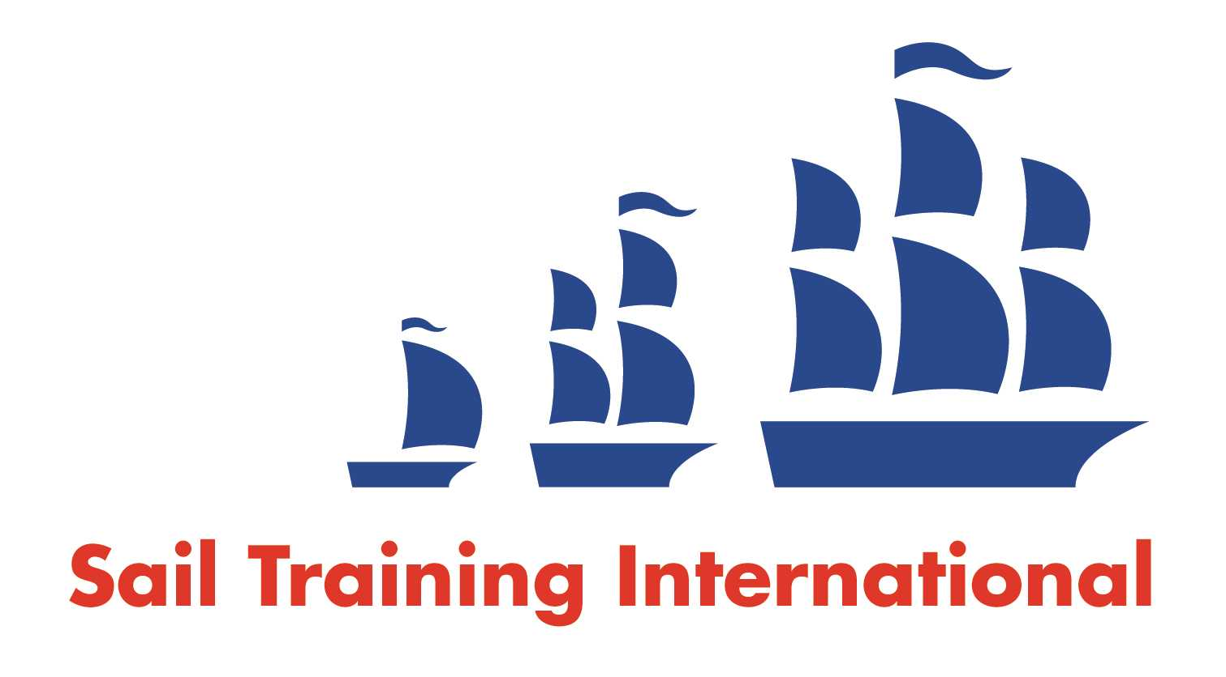
Sail Training International Paid/Volunteer Positions Submission Form

Editorial Policy

- This listing facility is free of charge but will only be accepted from sail training organisations and vessel operators that are members of their national sail training organisation or the Sail Training International Class A Tall Ships Forum.

- STI reserves the right not to publish a listing for any reason whatsoever.

- After completing the form, email to STI (office@sailtraininginternational.org) with copy to your National Sail Training Organisation for editorial review and approval prior to publishing on site.

Date of Posting | 03/04/2025
Name of Vessel | Ocean Spirit
Organisation Recruiting | Gordonstoun School
Name of Position | Sail Training Assistant Operations & Training Manager
Location of Position | Sail Training, Gordonstoun School, Elgin, Moray, IV30 5RF
Position is | Full Time | Yes | Seasonal  FTC 07/04/2025 –24/10/2025 | Yes
Remuneration | Paid | £27,194 pro rata p/a
Description of Position | Job Purpose: Gordonstoun has been leading the way in Hahnian Education for more than 80 years. Our uniquely broad curriculum provides challenge in the classroom, at sea and in the mountains, on the stage and on the sports fields and enables students to discover the truth in our motto – Plus Est En Vous – there is more in you. The key focus of this role is to support:  - the Sail Training Operations and Training Manager when deployed as relief skipper on Ocean Spirit of Moray and;  - the delivery of dinghy sailing and powerboating and;  - Gordonstoun International Summer School.  Responsibilities of all members of staff:  - Comply with Gordonstoun’s policies and procedures on Child Protection and Health and Safety.  - Contribute in a positive way to the ethos of the school in line with Gordonstoun’s values: Safe; Positive; Improving.  - Carry out any other task as required from time to time in order to support the School.  Major responsibilities of the role:  - Manage the logistics of Sail Training Voyages on Ocean Spirit of Moray, including transport, food, staffing and allocation of students.  - Liaise with Sail Training Operations and Training Manager, domestic services, refectory & transport to ensure efficient organisation of Sail Training voyages.  - Liaise with the Healthcare and pastoral leads to determine how to support students with health and wellbeing needs.  - Oversee daily vessel position and route plan monitoring.  - Liaise with ASTO and other funding bodies over the administration of external funds and bursaries available for Sail Training.  - Monitor the production of formal written reports about students as part of the school’s reporting system.  - Support the delivery of dinghy sailing and powerboating.  - Support the delivery of Gordonstoun International Summer School sail training.  Conditions:  The salary for this post is £27,194 p/a paid pro rata for the fixed term contract period.
Person to Contact | Erica Harrow recruitment@gordonstoun.org.uk  To apply please use the organisation website link.
Organisation’s website: | https://jobsearch.teacheroo.io/gordonstoun
Email | recruitment@gordonstoun.org.uk
Telephone | 01343 837 837
Fax
Closing Date for applications | 22 April 2025

