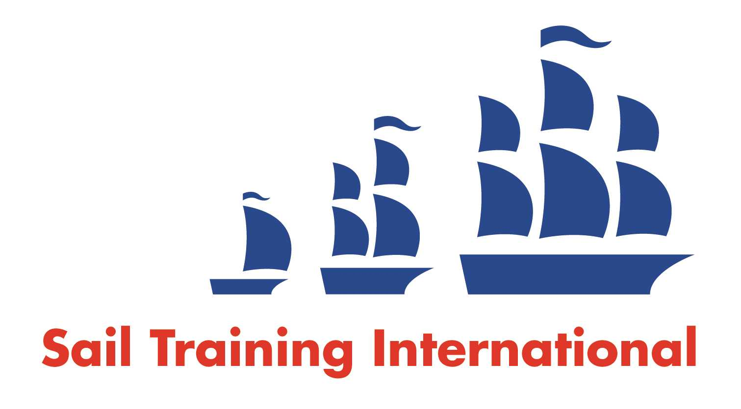
Sail Training International Paid/Volunteer Positions Submission Form

Editorial Policy

- This listing facility is free of charge but will only be accepted from sail training organisations and vessel operators that are members of their national sail training organisation or the Sail Training International Class A Tall Ships Forum.

- STI reserves the right not to publish a listing for any reason whatsoever.

- After completing the form, email to STI (office@sailtraininginternational.org) with copy to your National Sail Training Organisation for editorial review and approval prior to publishing on site.

Date of Posting | 25/04/2025
Name of Vessel | HMS Raleigh
Organisation Recruiting | Marine Society and Sea Cadets
Name of Position | Centre Manager - SCTC Raleigh
Location of Position | HMS Raleigh, Torpoint, Cornwall, PL11 2PD
Position is | Full Time | X | Seasonal
Remuneration | Paid | £36,700 gross per annum
Description of Position | We are seeking a Centre Manager who will manage the day-to-day operations of the cadet training centre based and operated from HMS Raleigh. This includes managing the Training Support Officer, Chief Instructor and the training throughput both planning and delivery, quality assurance seeking continual improvement in all that we do.  Our safety culture is critical, and this is focused on supporting volunteers so they can deliver safe, enjoyable yet challenging training to young people across the Royal Navy Cadet Forces. This along with responsibility for the material state and financial performance of the centre, as required by MSSC and in accordance with its policies and regulations.  The manager of the SCTC is responsible for ensuring the training centre is run in a manner appropriate for the residential training of young people in accordance with the MSSC’s approach to the provision of national training. Our training centre is hosted within HMS RALEIGH, and it is essential that the Centre Manager maintains a professional and collaborative relationship with all appropriate departments within HMS RALEIGH.
Person to Contact | Assistant Director of SC Learning, Tye Shuttleworth
Organisation’s website: | Centre Manager - SCTC Raleigh - MSSC
Email | tshuttleworth@ms-sc.org
Telephone
Fax
Closing Date for applications | 27/05/2025

