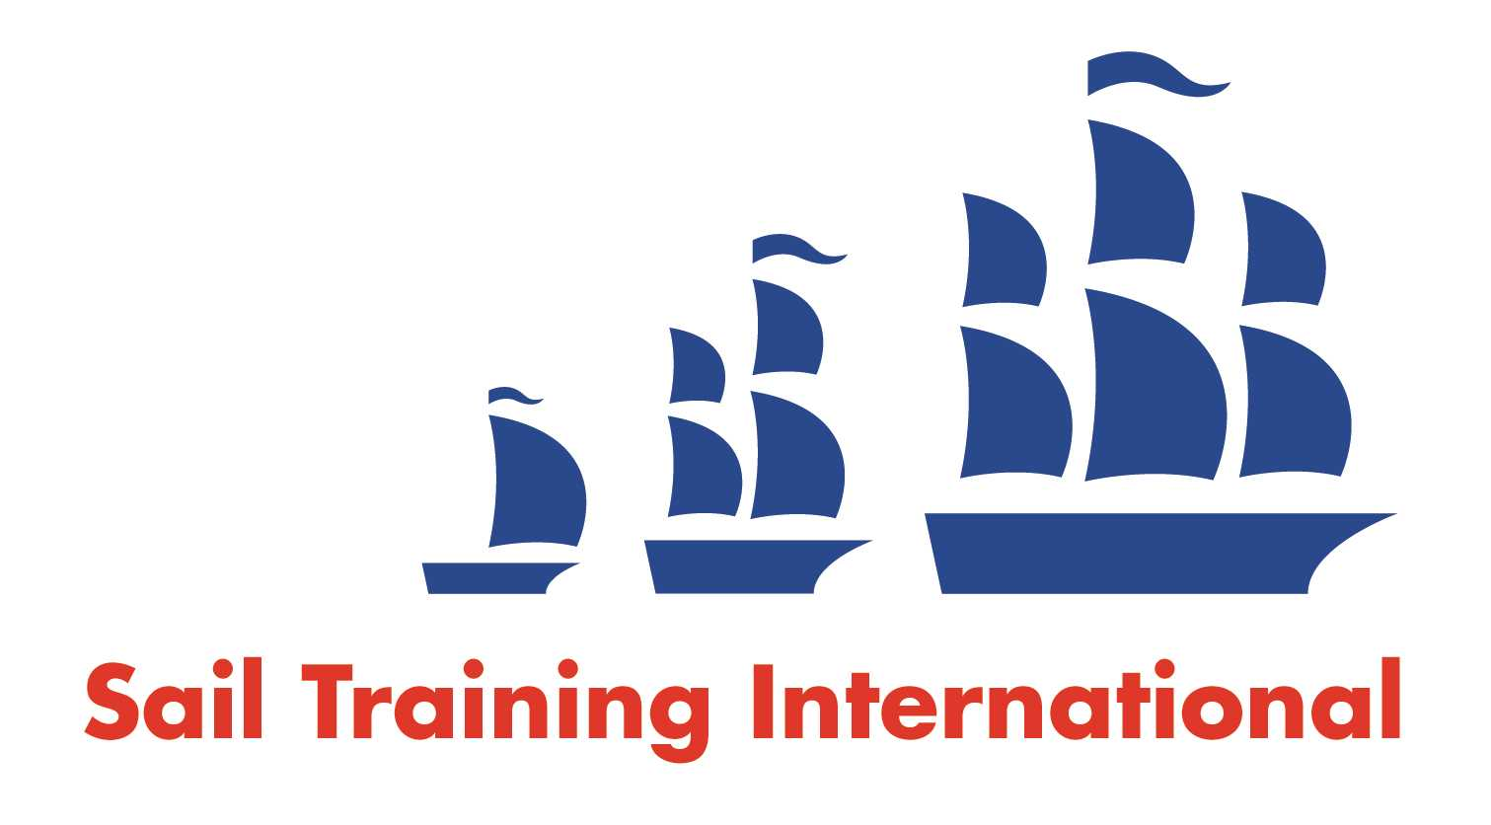
Sail Training International Paid/Volunteer Positions Submission Form

Editorial Policy

- This listing facility is free of charge but will only be accepted from sail training organisations and vessel operators that are members of their national sail training organisation or the Sail Training International Class A Tall Ships Forum.

- STI reserves the right not to publish a listing for any reason whatsoever.

- After completing the form, email to STI (office@sailtraininginternational.org) with copy to your National Sail Training Organisation for editorial review and approval prior to publishing on site.

Date of Posting | 05/03/2025
Name of Vessel | Various
Organisation Recruiting | Marine Society and Sea Cadets
Name of Position | Yacht Skipper
Location of Position | Gosport
Position is | Full Time | x | Seasonal
Remuneration | Paid | £  30,800 Per Annum
Description of Position | The primary purpose of the Yacht Skipper is to be responsible for the safe operation and navigation of any of the MSSC’s yachts allocated to them. The delivery of safe and effective sail training and the co-ordination and liaison of all routine safety checks and maintenance & repair of the offshore yachts.
Person to Contact | Recruitment team
Organisation’s website: | Yacht Skipper - MSSC (workable.com)
Email | receruitment@ms-sc.org
Telephone | 0207 564 7000
Fax
Closing Date for applications | 31/03/2025

