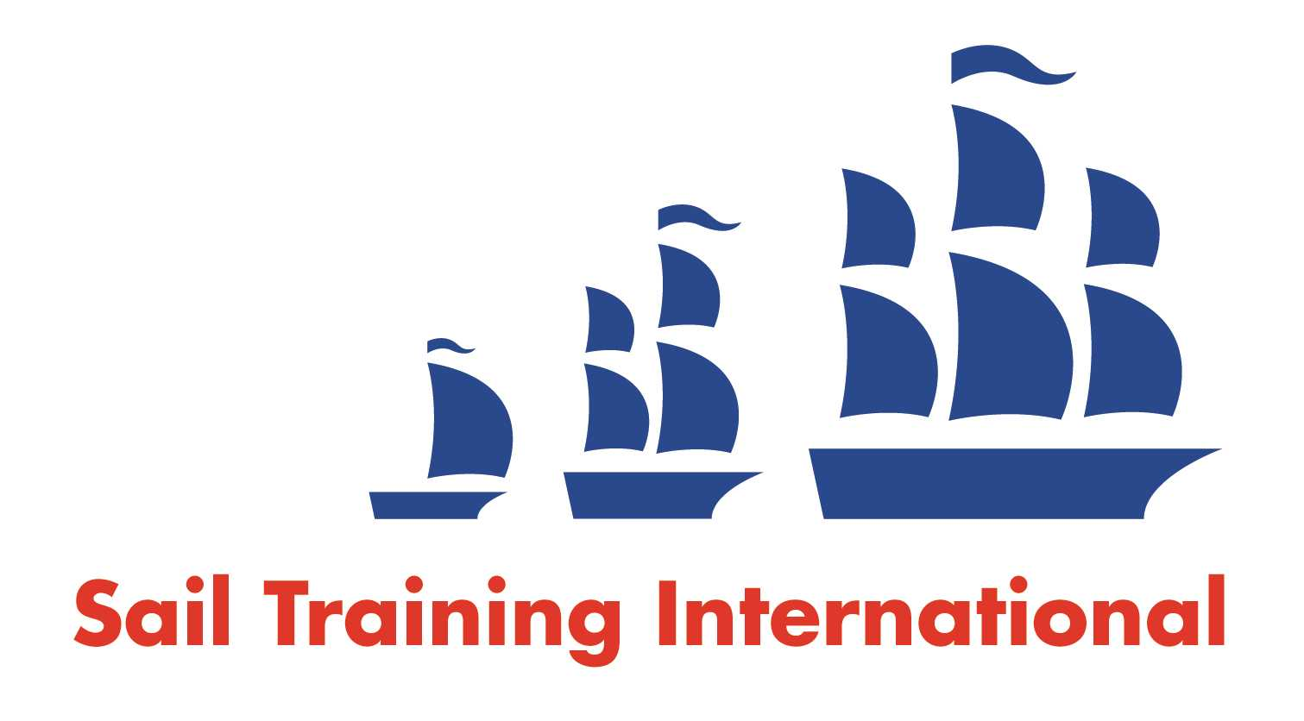
Sail Training International Paid/Volunteer Positions Submission Form

Editorial Policy

- This listing facility is free of charge but will only be accepted from sail training organisations and vessel operators that are members of their national sail training organisation or the Sail Training International Class A Tall Ships Forum.

- STI reserves the right not to publish a listing for any reason whatsoever.

- After completing the form, email to STI (office@sailtraininginternational.org) with copy to your National Sail Training Organisation for editorial review and approval prior to publishing on site.

Date of Posting | 05/03/2025
Name of Vessel | Various
Organisation Recruiting | Marine Society and Sea Cadets
Name of Position | First Lieutenant - TS Jack Petchey
Location of Position | Gosport
Position is | Full Time | x | Seasonal
Remuneration | Paid | £  32,500 Per Annum
Description of Position | The primary purpose of the 1st Mate / 1st Lieutenant on board the Marine Society’s Power Vessels is to act as the Second in Command of the TS Jack Petchey. You will be supporting the Commanding Officer to deliver high quality sail training experiences to cadets aged between 12-18. The vessels travel throughout the UK and near continent between March and November each year. You will be responsible for ensuring the safety, discipline, morale, welfare and day-to-day employment of permanent crew members, embarked personnel and cadets is appropriately managed. You will also act as the vessel’s Training Officer and Safety Officer.
Person to Contact | Recruitment team
Organisation’s website: | First Lieutenant - Jack Petchey - MSSC
Email | receruitment@ms-sc.org
Telephone | 0207 564 7000
Fax
Closing Date for applications | 08/04/2025

