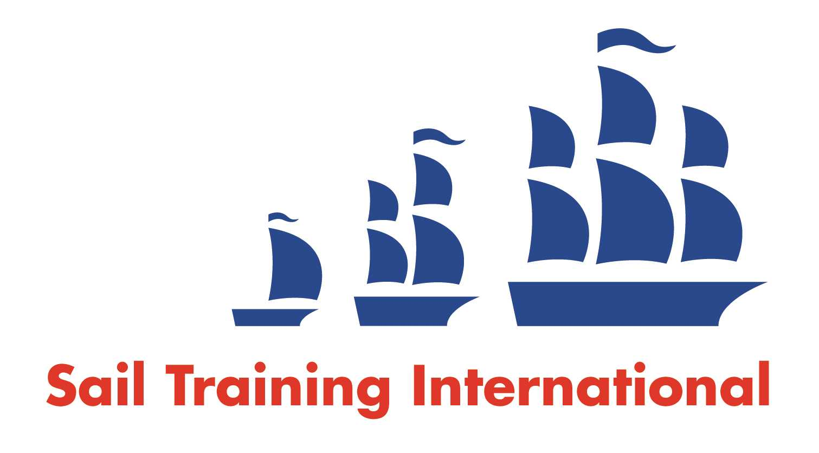
Sail Training International Paid/Volunteer Positions Submission Form

Editorial Policy

- This listing facility is free of charge but will only be accepted from sail training organisations and vessel operators that are members of their national sail training organisation or the Sail Training International Class A Tall Ships Forum.

- STI reserves the right not to publish a listing for any reason whatsoever.

- After completing the form, email to STI (office@sailtraininginternational.org) with copy to your National Sail Training Organisation for editorial review and approval prior to publishing on site.

Date of Posting | 31.03.25
Name of Vessel | Blue Clipper
Organisation Recruiting | Maybe Sailing Ltd
Name of Position | Engineer
Location of Position | Various, UK, Ireland, Europe, Caribbean
Position is | Full Time | X | Seasonal
Remuneration | Paid/Voluntary  (delete as appropriate) | €/$/£  (delete as appropriate)
Description of Position | ENGINEER REQUIRED  For Blue Clipper – 3 masted Schooner, 34 metres steel hull. See website for details:  www.maybe-sailing.com  Minimum qualifications:  AEC1, AEC2, STCW, ENG1  Duties:  Responsible for maintenance, servicing, general day to day running of all the ships machinery and equipment, both at sea and in refit.  Equipment includes but not limited to:  1 x Main Auxiliary Engine – Cummins type QSL9-405MCD1E. 405HP, fitted with twin disc gearbox.  2 x Valmet 30KW Sea Sets  1 x Sole 24KW Sea Set  Bow thruster  Water maker  Air Conditioning Unit  Boiler  All the ships equipment: Pumps, sprinkler system, firefighting equipment etc.  Salary negotiable, dependant on experience.
Person to Contact | Gette Nichols
Organisation’s website: | www.maybe-sialing.com
Email | info@maybe-sailing.com
Telephone | 01133919809
Fax
Closing Date for applications | 31.05.25

