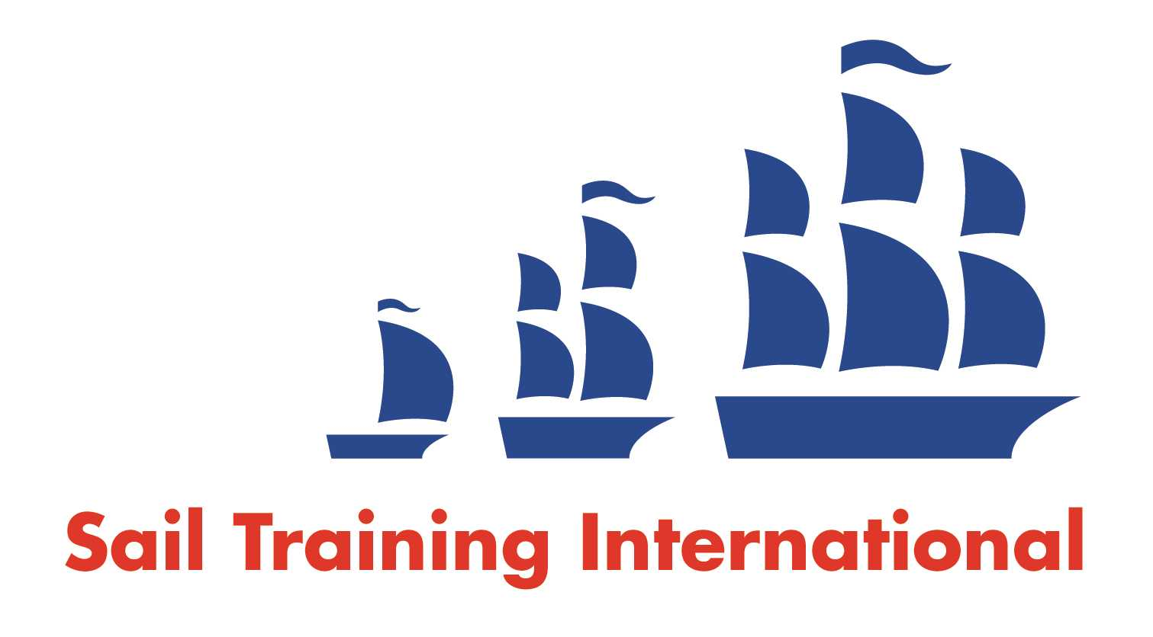
Sail Training International Paid/Volunteer Positions Submission Form

Editorial Policy

- This listing facility is free of charge but will only be accepted from sail training organisations and vessel operators that are members of their national sail training organisation or the Sail Training International Class A Tall Ships Forum.

- STI reserves the right not to publish a listing for any reason whatsoever.

- After completing the form, email to STI (office@sailtraininginternational.org) with copy to your National Sail Training Organisation for editorial review and approval prior to publishing on site.

Date of Posting | 05/03/2025
Name of Vessel | TS John Jerwood
Organisation Recruiting | Marine Society and Sea Cadets
Name of Position | Cook-Coxswain - TS John Jerwood
Location of Position | Operating from Gosport, but sailing around the UK and near-continent
Position is | Full Time | X | Seasonal
Remuneration | Paid | £27,600 gross per annum
Description of Position | We are seeking to appoint a Cook-Coxswain to one of our 24 metre power training vessels which operates out from Gosport, in Hampshire. The vessel undertakes 6-day voyages around the coastal waters of the UK and near continent for up to 12 Cadets (aged from between 12-18 years of age). Applicants should have the requisite experience and ability to cook for up to 18 people, together with the ordering and management of food stores. In the Coxswain part of the role, you will be also be responsible, in conjunction with the First Lieutenant, for management of the ship’s routine with key responsibility for Cadet administration, morale, safeguarding, welfare and discipline.
Person to Contact | Recruitment Team
Organisation’s website: | Chief Chef / Cook - Training Ship Royalist - MSSC (workable.com)
Email | receruitment@ms-sc.org
Telephone | 0207 564 7000
Fax
Closing Date for applications | 03/04/2025

