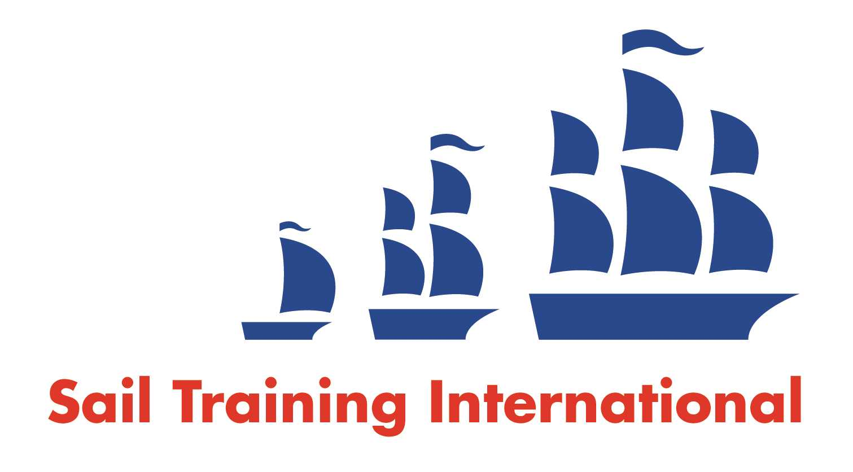
Sail Training International Paid/Volunteer Positions Submission Form

Editorial Policy

- This listing facility is free of charge but will only be accepted from sail training organisations and vessel operators that are members of their national sail training organisation or the Sail Training International Class A Tall Ships Forum.

- STI reserves the right not to publish a listing for any reason whatsoever.

- After completing the form, email to STI (office@sailtraininginternational.org) with copy to your National Sail Training Organisation for editorial review and approval prior to publishing on site.

Date of Posting | 21/03/2025
Name of Vessel | N/A
Organisation Recruiting | Marine Society and Sea Cadets
Name of Position | Boat Station Manager – Royal Docks
Location of Position | Royal Docks Boat Station, London Regatta Centre, Dockside Road, London, E16 2QT
Position is | Full Time | X | Seasonal
Remuneration | Paid | £29,000 gross per annum
Description of Position | Are you a watersports manager looking for a new opportunity?  The Manager is an employee of the Marine Society & Sea Cadets, and is a member of the Sea Cadets Learning Department, based at our Whale Island Boat Station. The post holder is required to hold and maintain the following qualifications as a condition of employment: RYA Senior Dinghy Instructor and RYA Powerboat Instructor.  The primary purpose of the role is to manage a water-sports training facility in the London Docklands area for all Sea Cadet Units and other affiliates to the Boat Station.
Person to Contact
Organisation’s website: | Boat Station Manager - Royal Docks Boat Station - MSSC
Email | recruitment@ms-sc.org
Telephone
Fax
Closing Date for applications | 18/04/2025

