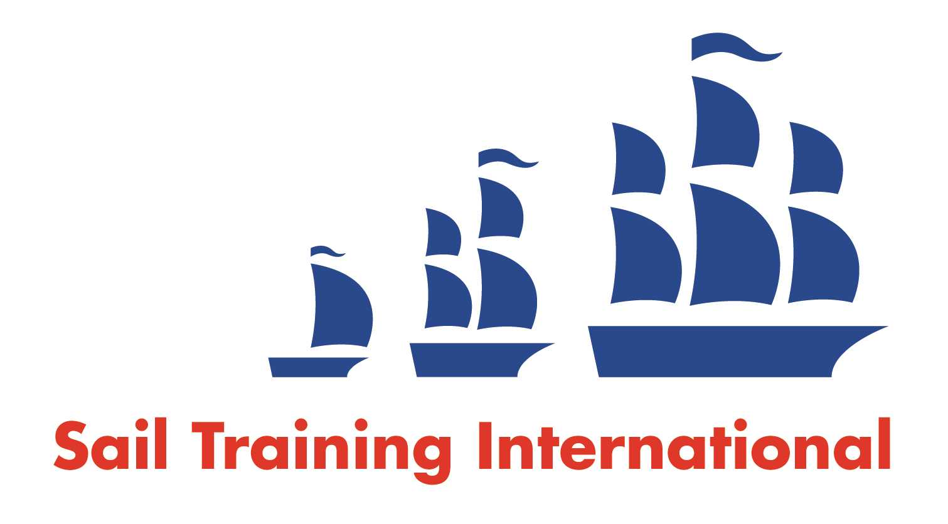
Sail Training International Positions Sought Submission Form

Editorial Policy

- This listing facility is open to any vessel operator or organisation involved in sail training.

- STI reserves the right not to publish a listing for any reason whatsoever.

- After completing the form, email to STI (office@sailtraininginternational.org) for editorial review prior to publishing on site. You can expect your advertisement to appear within 2-3 business days.

- Your listing will be automatically removed after three months unless you indicate an earlier date. To retain a listing beyond three months, please notify STI before the end of the three month period.

Date of Posting | 12 February 2025
Name | PJIE
Position Sought | Watch leader, Deckhand, Chef cook
Location preference | Worldwide
Seasonal |  | Paid
Description of Position Sought  (max 100 words) | As I work towards becoming a captain, I am seeking a position on sailing ships to further develop my nautical skills. I am also passionate about healthy food, particularly vegetarian and vegan cuisine, and have experience as a chef on ships. Please find my CV attached for your review.
Qualifications | Deckhand (Deck Rating), watchkeeping certificate (STCW II/4)
Email | Fpmail31&zohomail.eu
Telephone | +33 6 85 34 45 63

