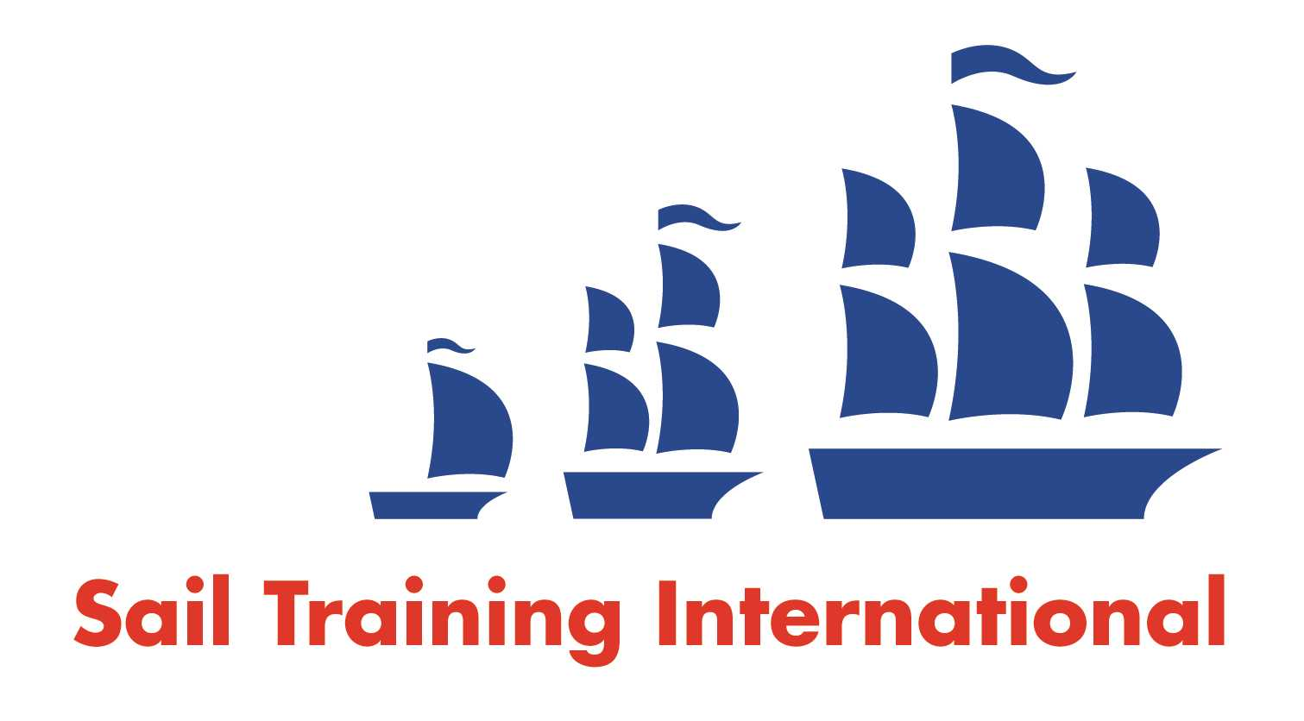

**Sail Training International Paid/Volunteer Positions Submission Form**

**Editorial Policy**

1. This listing facility is free of charge but will only be accepted from sail training organisations and vessel operators that are members of their national sail training organisation or the Sail Training International Class A Tall Ships Forum.
2. STI reserves the right not to publish a listing for any reason whatsoever.

1. After completing the form, email to **STI** ([office@sailtraininginternational.org](mailto:office@sailtraininginternational.org)) with copy to your **National Sail Training Organisation** for editorial review and approval prior to publishing on site.

|  |  |  |  |  |
| --- | --- | --- | --- | --- |
| **Date of Posting** | 17/02/2025 | | | |
| **Name of Vessel** | Swan LK243 | | | |
| **Organisation Recruiting** | The Swan Trust SCIO | | | |
| **Name of Position** | Bosun | | | |
| **Location of Position** | Based in Lerwick, Shetland Islands | | | |
| **Position is** | **Full Time** |  | **Seasonal** | X |
| **Remuneration** | **Paid**  (delete as appropriate) | **£up to £25,400 pro rata**  (delete as appropriate) | | |
| **Description of Position** | Are you looking for a summer adventure?  Have you got what it takes to spend 4 months sailing international waters, making new friends, and supporting crew and passengers aboard a traditional sailing boat; exploring the stunning Shetland coastline and taking part in the world famous Tall Ships Races?  Shetland’s own tall ship, Swan, is seeking a Bosun to sail on board supporting the skipper and mate with on board and on shore tasks during the busy summer 2025 season.  This is an ideal opportunity for a young person looking to gain more time at sea towards a qualification, or to further their own previous sail training experience. It would also be suitable for an older person with a keen interest in sailing and a sense of adventure.  No formal qualifications are necessary, but some sailing experience is essential as the appointed person will be required to run the deck in a support role to the first mate, which will include instructing passengers in a clear manner and ensuring the safety of all on board.  The trip schedule during this time will include day sails to celebrate the 125th anniversary of the launch of Swan, public trips to Norway, Shetland’s west coast and north isles, Fair Isle and the north east coast of Scotland. School trips will also feature, and a six week Tall Ships Race voyage which will include visits to the ports of Dunkirk (France), Aberdeen, Kristiansand (Norway) and Esbjerg (Denmark).  The post is a fixed term role from 1st May to 31st August.  The salary will be £25,400 pro rata, dependent on age and experience, with 11 days paid leave given at times to be agreed.  Accommodation and meals will be provided on board for the duration of the contract.  **SWAN BOSUN - Responsibilities and Duties**   1. Assist the Skipper and Mate with ensuring the vessel and its equipment are maintained in a safe and seaworthy condition at all times. 2. Support the skipper with safety, morale and welfare of crew and passengers. Encourage all passengers to be engaged and included in activities. 3. Running the deck in a Bosun role, supporting the Mate in leading crew and passengers in sailing tasks. 4. Ensure that any instruction issued to the crew and passengers is in a clear and simple manner, bearing in mind their experience, or lack of it. 5. Report any defects or other matters that could affect the safe operation of the Swan or could present a risk of damage to the environment to the Skipper. 6. Ensure that all crew and passengers take reasonable care for the health and safety of themselves and of other persons who may be affected by their acts or omissions, and to co-operate with the Trust to ensure that any requirement under Health and Safety at Work Act 1974 and Merchant Shipping Acts is performed or complied with. 7. Assist on board with food preparation and supervision. 8. Coordinate arrangements for provisioning, in line with shopping lists and meal plans prepared by the Mate (or Skipper), and in liaison with on-shore volunteers where required. Safe and efficient stowing and storage of food and other provisions brough on board. 9. Champion the Swan and raise the profile of the Trust. 10. Avoid casual commenting to the press, radio, television, or online with regard to the Swan. Official interviews should have approval of the Chair of the Trust. Any approaches of a sensitive nature should be politely referred to the Chair of the Trust. | | | |
| **Person to Contact** | Emma Miller | | | |
| **Organisation’s website:** | www.swantrust.com | | | |
| **Email** | emma@swantrust.com | | | |
| **Telephone** | 07753806095 | | | |
| **Fax** |  | | | |
| **Closing Date for applications** | 03/03/2025 | | | |