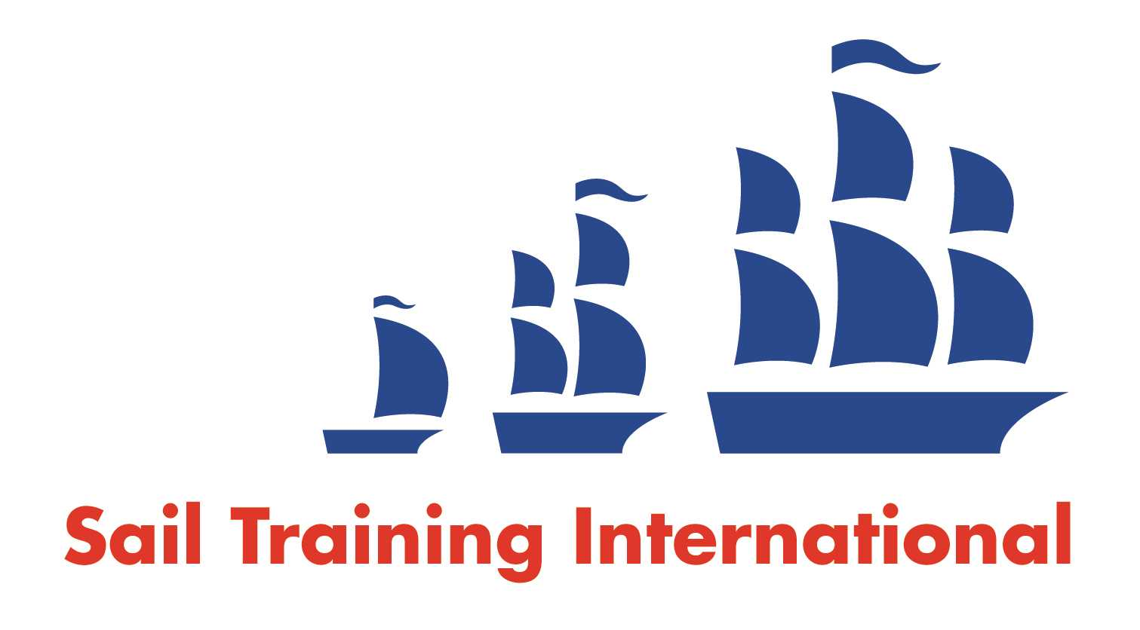
Sail Training International Paid/Volunteer Positions Submission Form

Editorial Policy

- This listing facility is free of charge but will only be accepted from sail training organisations and vessel operators that are members of their national sail training organisation or the Sail Training International Class A Tall Ships Forum.

- STI reserves the right not to publish a listing for any reason whatsoever.

- After completing the form, email to STI (office@sailtraininginternational.org) with copy to your National Sail Training Organisation for editorial review and approval prior to publishing on site.

Date of Posting | 25.02.25
Name of Vessel | Maybe
Organisation Recruiting | Maybe Sailing Ltd
Name of Position | Volunteer Deckhand
Location of Position | Uk and Ireland
Position is | Full Time |  | Seasonal | x
Remuneration | Paid/Voluntary  (delete as appropriate) | €/$/£  (delete as appropriate)
Description of Position | Maybe Sailing relies heavily on volunteers to help onboard Tall Ship Maybe throughout the sailing season. Volunteer placements are for a minimum of 2 weeks or for longer periods of time. Volunteering offers an excellent opportunity to gain experience and knowledge onboard our vessels.  We are looking for volunteers for various dates on board TS Maybe starting in May 2025. Some sailing experience is required and experience of youth training would be advantageous.  From May to August our voyages will be Irish coast youth voyages then September onwards in Uk and mediterranean waters for guest voyages.
Person to Contact | Gette Nichols
Organisation’s website: | www.maybe-sailing.com
Email | info@maybe-sailing.com
Telephone | 0113 3919809
Fax
Closing Date for applications | Open ended

