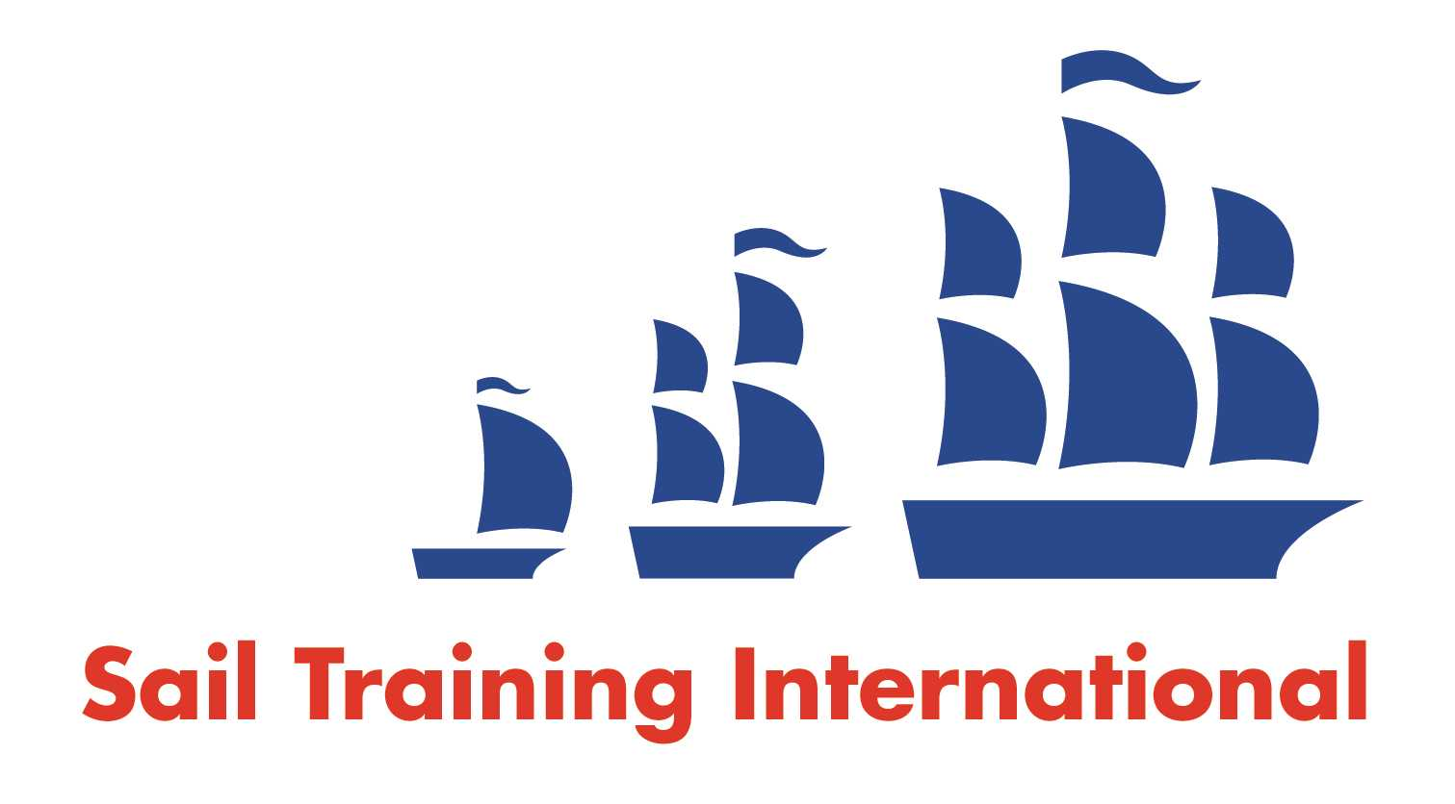
Sail Training International Paid/Volunteer Positions Submission Form

Editorial Policy

- This listing facility is free of charge but will only be accepted from sail training organisations and vessel operators that are members of their national sail training organisation or the Sail Training International Class A Tall Ships Forum.

- STI reserves the right not to publish a listing for any reason whatsoever.

- After completing the form, email to STI (office@sailtraininginternational.org) with copy to your National Sail Training Organisation for editorial review and approval prior to publishing on site.

Date of Posting | 28/02/2025
Name of Vessel | N/A
Organisation Recruiting | Marine Society and Sea Cadets
Name of Position | Chief Instructor – SCTC Raleigh
Location of Position | SCTC Raleigh, Torpoint, Cornwall, PL11 2PD
Position is | Full Time | X | Seasonal
Remuneration | Paid | £29,000 gross per annum
Description of Position | We are looking for someone who will deliver and support high quality land based, face to face and virtual training to both our cadets and volunteers, creating a highly impactful national training experience for our cadets guided by the customs and traditions of the Royal Navy. You will lead volunteers and sessional instructors to ensure high quality delivery and manage the day-to-day training, whilst ensuring the health, safety and safeguarding of all whom you are training. You will work closely with the Centre Manager to support the day-to-day operations.  As the Chief Instructor you will be a driving force for the quality delivery of training at the centre. You will be instrumental in facilitating and delivering life changing, positive experiences for our young people. We are seeking a dedicated practitioner who excels in a diverse environment and aims to achieve fulfilment by working with young people and assisting our 4500 volunteers to deliver the Sea Cadet Experience.
Person to Contact | Boat Station Manager, Marc Styles
Organisation’s website: | Chief Instructor - SCTC Raleigh - MSSC
Email | mstyles@ms-sc.org
Telephone
Fax
Closing Date for applications | 21/03/2025

