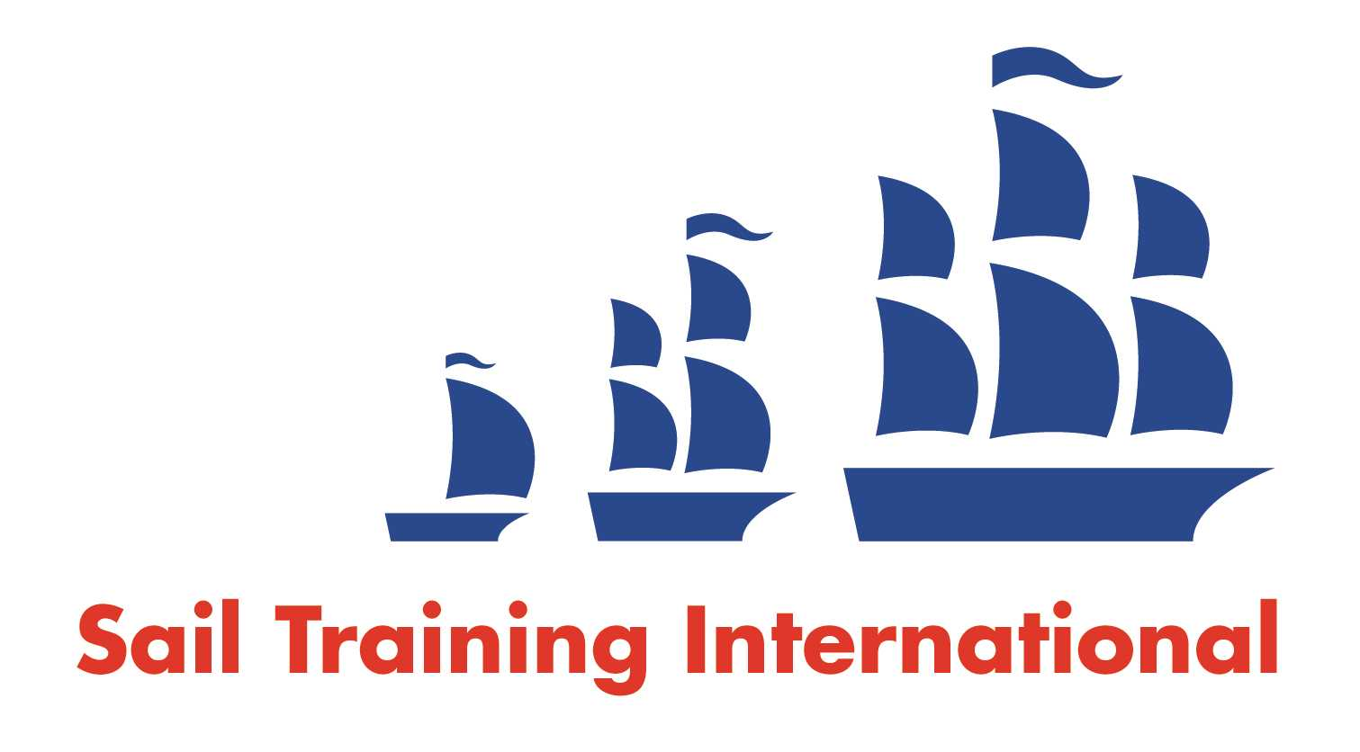
Sail Training International Positions Sought Submission Form

Editorial Policy

- This listing facility is open to any vessel operator or organisation involved in sail training.

- STI reserves the right not to publish a listing for any reason whatsoever.

- After completing the form, email to STI (office@sailtraininginternational.org) for editorial review prior to publishing on site. You can expect your advertisement to appear within 2-3 business days.

- Your listing will be automatically removed after three months unless you indicate an earlier date. To retain a listing beyond three months, please notify STI before the end of the three month period.

Date of Posting | 25/01/2025
Name | Daniel Eatough
Position Sought | Deckhand
Location preference | UK or Europe
Full Time / Seasonal  (delete as appropriate) |  | Paid  (delete as appropriate)
Description of Position Sought  (max 100 words) | I would most like to fill a deckhand role, any requirements for engineer is outside of my experience but something I am keen to learn more about. I am looking to spend time onboard a larger vessel and to build up my sea time and experience to further my qualifications and career. An organisation where I can sail year round or return season after season with more responsibility as my experience grows would be perfect.
Qualifications | ENG1  STCW 95+10  Yachtmaster Offshore Commercially Endorsed  Yachtmaster Shorebased Theory  RYA Diesel engine  RYA Advanced Dinghy / Windsurf Instructor  RYA PB2
Email | djtoff@live.co.uk
Telephone | +44 7493 028 419

