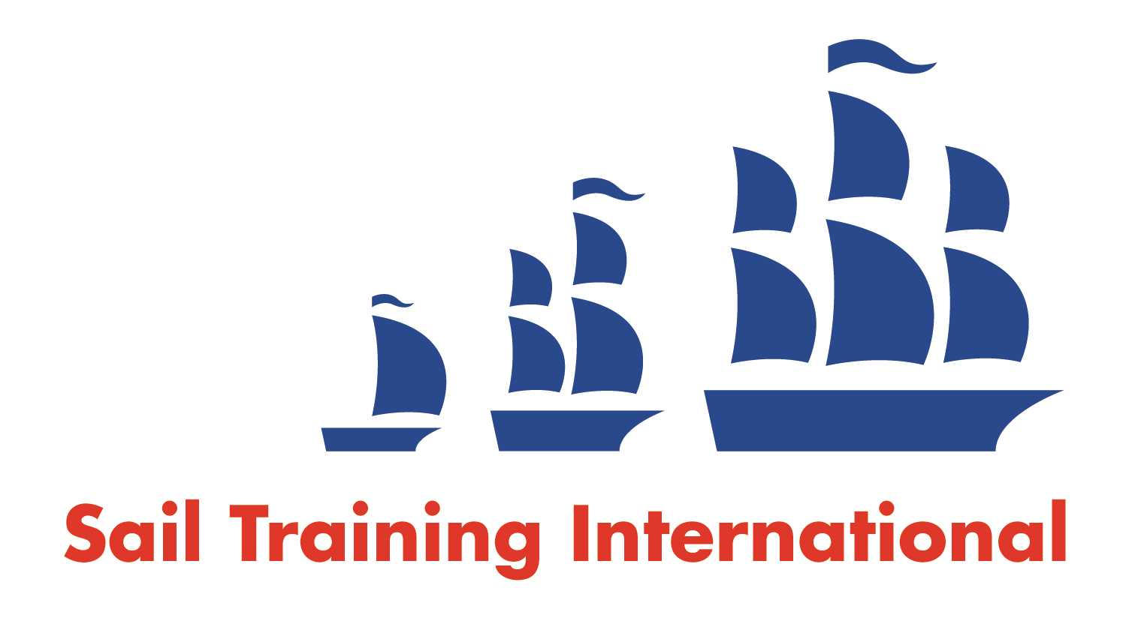

**Sail Training International Positions Sought Submission Form**

**Editorial Policy**

1. This listing facility is open to any vessel operator or organisation involved in sail training.
2. STI reserves the right not to publish a listing for any reason whatsoever.
3. After completing the form, email to **STI** ([office@sailtraininginternational.org](mailto:office@sailtraininginternational.org)) for editorial review prior to publishing on site. You can expect your advertisement to appear within 2-3 business days.
4. Your listing will be automatically removed after three months unless you indicate an earlier date. To retain a listing beyond three months, please notify STI before the end of the three month period.

|  |  |  |
| --- | --- | --- |
| **Date of Posting** | **December 2024** | |
| **Name** | **Christopher Wren** | |
| **Position Sought** | **Captain or Captain/Engineer** | |
| **Location preference** | **Any worldwide** | |
| **Full Time / ~~Seasonal~~**  (delete as appropriate) | | **Paid / Voluntary**  (delete as appropriate) **Either** |
| **Description of Position Sought**  **(max 100 words)** | **To act as captain and chief engineer on a sailing ship.**  **To pass on knowledge gained in a lifetime at sea on sailing ships to a younger generation.**  **To transform lives of everyone and anyone to the next level!** | |
| **Qualifications** | **Yachtmaster Commercial. Chief Engineer.** | |
| **Email** | **chris@chriswren.co.uk** | |
| **Telephone** | **+44 7967 147603** | |