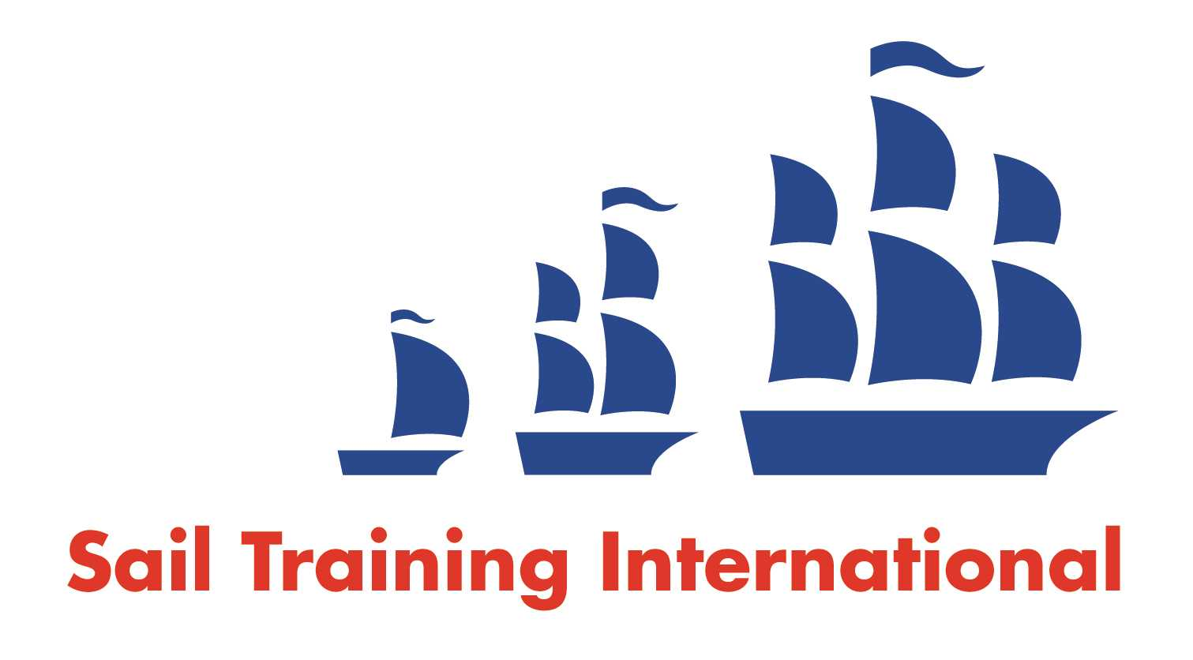
Sail Training International Paid/Volunteer Positions Submission Form

Editorial Policy

- This listing facility is free of charge but will only be accepted from sail training organisations and vessel operators that are members of their national sail training organisation or the Sail Training International Class A Tall Ships Forum.

- STI reserves the right not to publish a listing for any reason whatsoever.

- After completing the form, email to STI (office@sailtraininginternational.org) with copy to your National Sail Training Organisation for editorial review and approval prior to publishing on site.

Date of Posting | October 10, 2024
Name of Vessel | Pacific Grace and Pacific Swift
Organisation Recruiting | S.A.L.T.S. (Sail and Life Training Society)
Name of Position | Professional Crew (Captain, First Mate, Bosun, Watch Officer, Cook)
Location of Position | Victoria, BC, Canada
Position is | Full Time | X | Seasonal
Remuneration | Paid | $40K-$90K
Description of Position | Do you have a passion for helping youth grow, love spending time outdoors, and want to sail on board a tall ship? Apply now to join the SALTS crew! Not an experienced sailor? That’s okay – SALTS provides all training necessary to safely operate our ships and fulfill your role. Experienced sailor? We have senior officer roles too. We are currently accepting applications for the paid crew positions of Captain, First Mate, Bosun, Watch Officer, and Cook, with positions starting as soon as suitable candidates are available.  SALTS is an independent Christian-based registered charity located in Victoria BC. We seek to create an environment that is caring and respectful, where young people from all walks of life are encouraged, inspired, and heard. If you are passionate about supporting our mission and values, we want to hear from you! All crew members guide and mentor the young people who sail with us, and each role has an additional focus on either group leadership, ship maintenance, or cooking. SALTS operates two schooners based out of Victoria BC, and each year 1700 young people participate in our program as trainees, on 4-10 day trips in coastal BC waters. Annual crew salaries range from $40K-$90K (up to $109K total compensation). Employment for all roles is typically full-time, year-round, but we also have need for some experienced relief (part-time) crew members.  To learn more and apply, visit salts.ca/careers
Person to Contact | Please apply online at salts.ca/careers
Organisation’s website: | www.salts.ca/
Email | info@salts.ca
Telephone | +1-888-383-6811
Fax
Closing Date for applications | January 1, 2024

