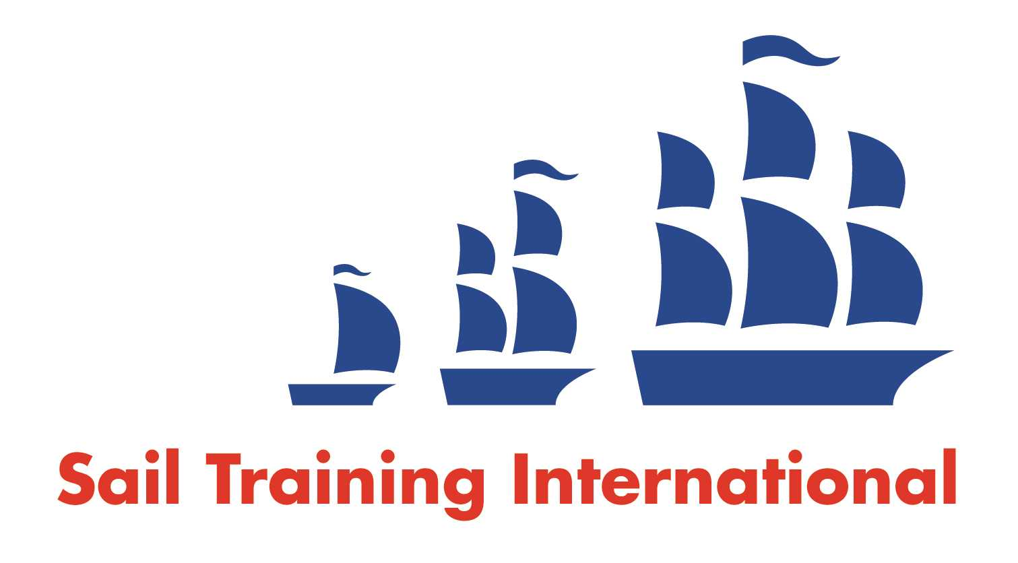
Sail Training International Positions Sought Submission Form

Editorial Policy

- This listing facility is open to any vessel operator or organisation involved in sail training.

- STI reserves the right not to publish a listing for any reason whatsoever.

- After completing the form, email to STI (office@sailtraininginternational.org) for editorial review prior to publishing on site. You can expect your advertisement to appear within 2-3 business days.

- Your listing will be automatically removed after three months unless you indicate an earlier date. To retain a listing beyond three months, please notify STI before the end of the three month period.

Date of Posting | October 2024
Name | Guillaume Marois
Position Sought | Chief Engineer/2nd Engineer
Location preference | Any worldwide
Full Time | Paid / Voluntary Either
Description of Position Sought  (max 100 words) | Engineers position on a sailing ship.  Eager to work on and fix anything, ancient to brand new, and train/teach those interested in learning more about how engines, pumps, and more work.  World touring boats of particular interest.
Qualifications | 4th engineers license (Canada), stick welding certified, several ocean crossings on sailing vessels
Email | guillaumemarois@hotmail.om
Telephone | +1 581 777 3129

