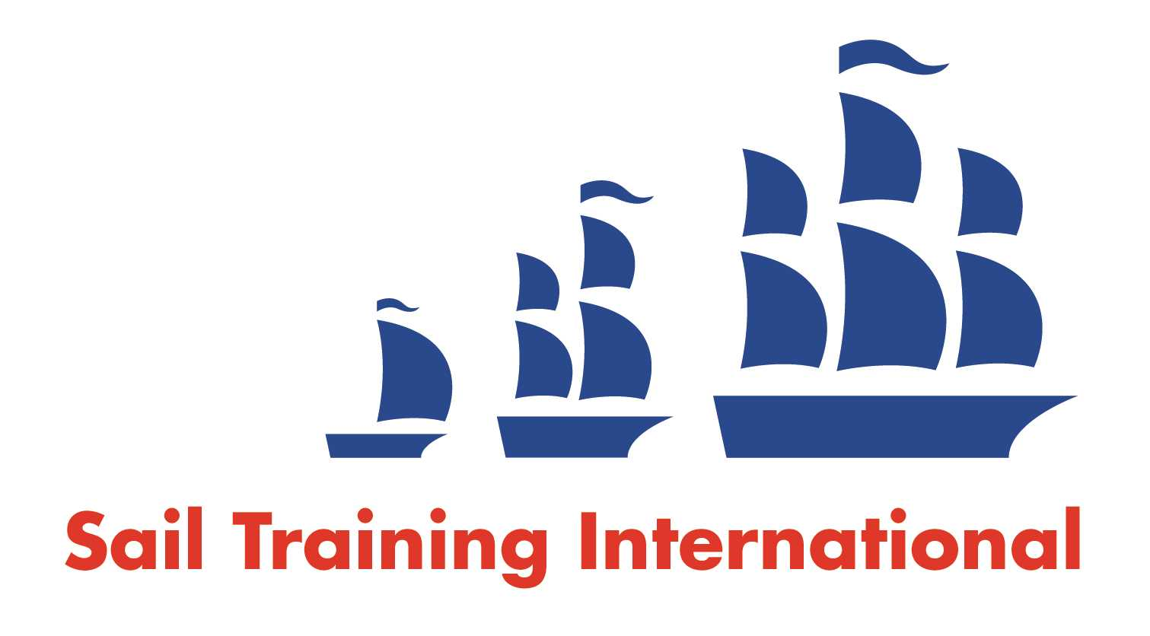
Sail Training International Paid/Volunteer Positions Submission Form

Editorial Policy

- This listing facility is free of charge but will only be accepted from sail training organisations and vessel operators that are members of their national sail training organisation or the Sail Training International Class A Tall Ships Forum.

- STI reserves the right not to publish a listing for any reason whatsoever.

- After completing the form, email to STI (office@sailtraininginternational.org) with copy to your National Sail Training Organisation for editorial review and approval prior to publishing on site.

Date of Posting | 25/10/2024
Name of Vessel | TS Jack Petchey
Organisation Recruiting | Marine Society and Sea Cadets
Name of Position | Marine Engineer – TS Jack Petchey
Location of Position | Operating from Gosport, but sailing around the UK and near-continent
Position is | Full Time | X | Seasonal
Remuneration | Paid | £33,000 gross per annum
Description of Position | The primary purpose of the Marine Engineer is to deliver the maintenance and safe operation of all machinery on board the vessel. Responsibility spans the hull, structure, main and auxiliary machinery, electrical and electronic systems, fuel, water, LP air and hydraulics, and the planning and execution of off-season maintenance periods. A comprehensive level of advice and support to the onboard Engineer is provided by our two, office based, Engineering Technical staff.  Applicants should have the requisite experience and should ideally have completed an approved engine course. They should also either hold a current Seafarer Medical Certificate or be willing to obtain one. The ability to work effectively with young people as well as the permanent and relief crew members is essential. Ship system familiarisation, child safeguarding and any necessary sea safety course refresher training will be given to the successful applicant.
Person to Contact | MSSC's Offshore Office
Organisation’s website: | Marine Engineer - TS Jack Petchey - MSSC
Email
Telephone | 07798675147
Fax
Closing Date for applications | 23/11/2024

