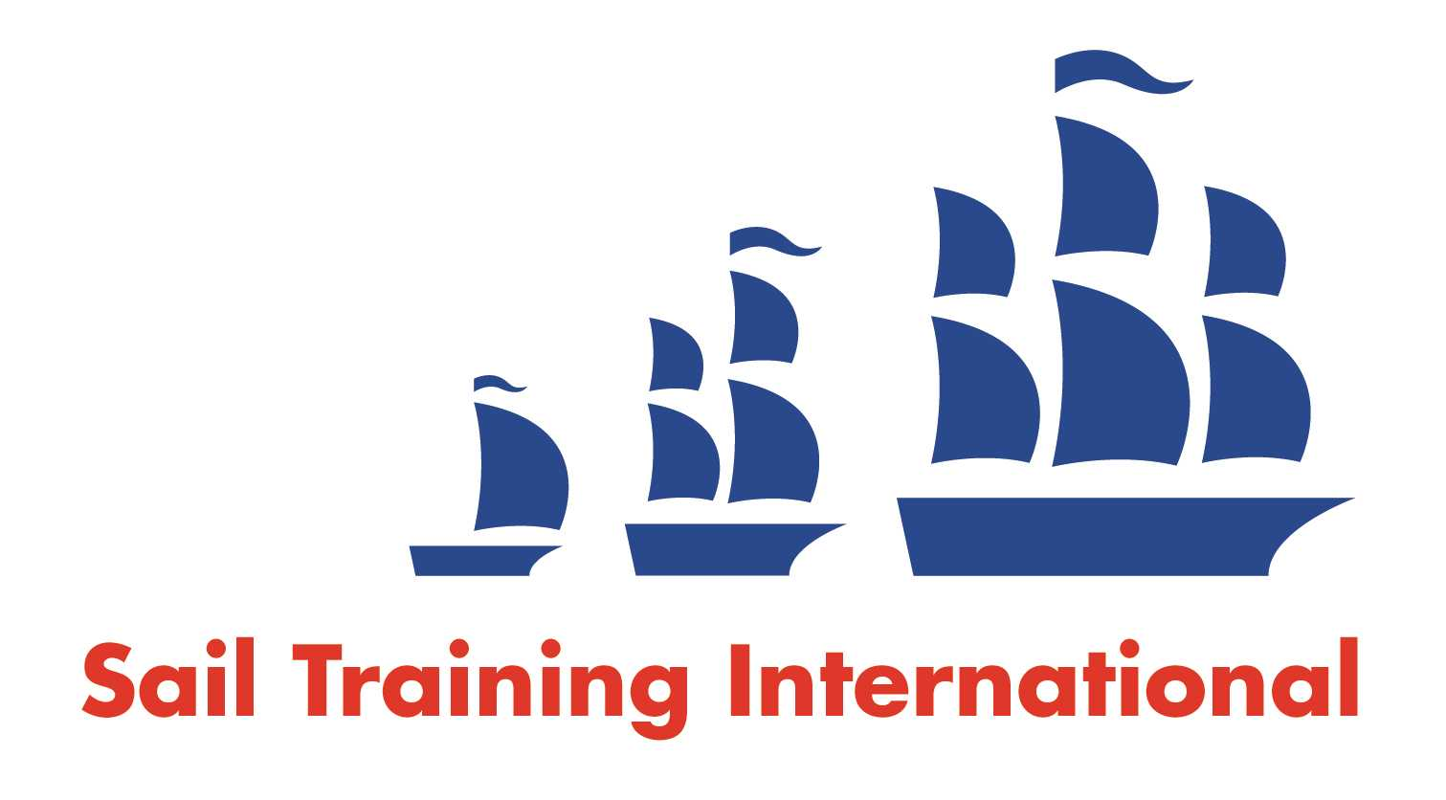
Sail Training International Paid/Volunteer Positions Submission Form

Editorial Policy

- This listing facility is free of charge but will only be accepted from sail training organisations and vessel operators that are members of their national sail training organisation or the Sail Training International Class A Tall Ships Forum.

- STI reserves the right not to publish a listing for any reason whatsoever.

- After completing the form, email to STI (office@sailtraininginternational.org) with copy to your National Sail Training Organisation for editorial review and approval prior to publishing on site.

Date of Posting | 11/10/2024
Name of Vessel | N/A
Organisation Recruiting | Marine Society and Sea Cadets
Name of Position | Instructor – Weymouth
Location of Position | Weymouth National Boat Centre (WNBC), Dorset, DT4 8TZ
Position is | Full Time | X | Seasonal
Remuneration | Paid | £27,000 gross per annum
Description of Position | The Instructor is instrumental in facilitating and delivering life changing, positive experiences for young people. They will work within the team to support both volunteers and young people whilst providing high quality, role model delivery. The post will require experience of dealing with people of all ages/backgrounds, in the delivery of activities, and equipment/facilities maintenance.  As a team player, you will report to the Centre Manager, with a functional line from the Chief Instructor.  We are looking for a passionate practitioner, with a background in delivering activities both on and off the water, and experience of maintenance and procedures management. Experience of working with young people is essential.
Person to Contact | Sarah Cornick (Centre Manager)
Organisation’s website: | Instructor - Weymouth - MSSC (workable.com)
Email | scornick@ms-sc.org
Telephone
Fax
Closing Date for applications | 04/11/2024

