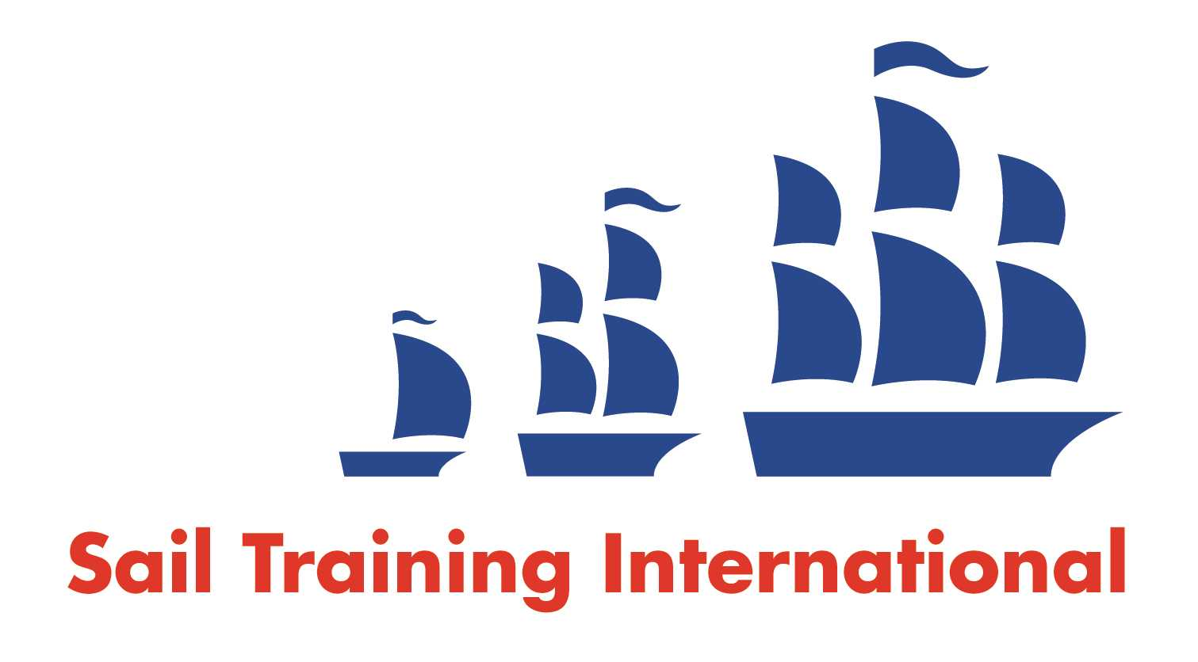
Sail Training International Paid/Volunteer Positions Submission Form

Editorial Policy

- This listing facility is free of charge but will only be accepted from sail training organisations and vessel operators that are members of their national sail training organisation or the Sail Training International Class A Tall Ships Forum.

- STI reserves the right not to publish a listing for any reason whatsoever.

- After completing the form, email to STI (office@sailtraininginternational.org) with copy to your National Sail Training Organisation for editorial review and approval prior to publishing on site.

Date of Posting | 18/10/2024
Name of Vessel | TS Royalist
Organisation Recruiting | Marine Society and Sea Cadets
Name of Position | Bosun – TS Royalist
Location of Position | Fort Blockhouse, Gosport, PO12 2AB
Position is | Full Time | X | Seasonal
Remuneration | Paid | £37,600 gross per annum
Description of Position | The ideal applicant will have experience of square rig sailing, general seamanship and maintenance of sailing vessels. The Bosun is primarily responsible for care and management of all upper deck equipment, spars, sails, yards, berthing wires, ropes, fenders, awnings, flags, fittings on deck and aloft. Mainly employed on the foredeck, the Bosun must have the ability to lead and manage a team and to work effectively with young people.  The successful applicant will be required to become a uniformed member of the Sea Cadet Corps and to undertake an enhanced Criminal Records Bureau check. The post holder will be responsible to the Commanding Officer TS Royalist, through the Sailing Master.
Person to Contact | Angela Morris
Organisation’s website: | Bosun - TS Royalist - MSSC
Email | amorris@ms-sc.org
Telephone
Fax
Closing Date for applications | 31/10/2024

