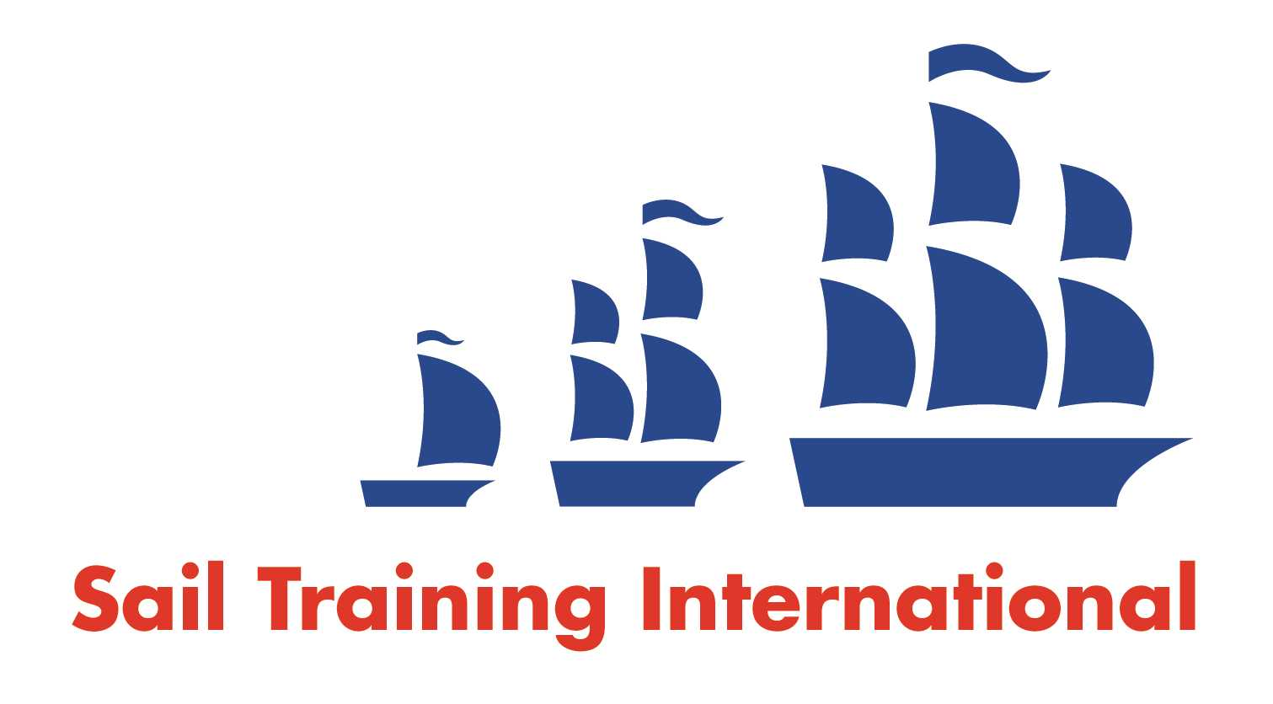
Sail Training International Positions Sought Submission Form

Editorial Policy

- This listing facility is open to any vessel operator or organisation involved in sail training.

- STI reserves the right not to publish a listing for any reason whatsoever.

- After completing the form, email to STI (office@sailtraininginternational.org) for editorial review prior to publishing on site. You can expect your advertisement to appear within 2-3 business days.

- Your listing will be automatically removed after three months unless you indicate an earlier date. To retain a listing beyond three months, please notify STI before the end of the three month period.

Date of Posting | 26/09/2024
Name | Lorna Sheaff
Position Sought | Medic/Nurse
Location preference | N/A
Seasonal  (delete as appropriate) |  | Voluntary  (delete as appropriate)
Description of Position Sought  (max 100 words) | I have worked for 6 years in A&E and have specialised in Resuscitation Medicine. I have a good basis of knowledge about long term conditions, minor injuries and trauma/life-threatening problems.  In August 2024 I was on board the Tall Ship The Pelican for two weeks. I immersed myself in the team and took on duties of a deckhand including night watches and cleaning/galley rota roles. I am eager to learn new skills around sailing and have attended a sea rescue course previously to gain experience around how to effectively practice medicine at sea, and how to handle emergencies on board.  Prior to sailing on The Pelican I only had experience of small dinghy racing, however I am very comfortable at sea and am working to develop my knowledge of Tall Ships and how to help the crew with their responsibilities. I am keen to spend time applying my medical knowledge to more challenging environments. I am passionate about caring for the health needs of people who are taking part in these experiences, and ensuring safety on board.
Qualifications | . Bsc Nursing- University of Southampton 2018  . Sea Rescue Course- RYA- 2023  . Advanced Life Support Instructor- University Hospital Coventry and Warwickshire- 2024  . Trauma Immediate Life Support- University Hospital Coventry and Warwickshire- 2023  . Disaster and Emergency Management- FutureLearn- 2022
Email | sheaffl@yahoo.co.uk
Telephone | 07580752529

