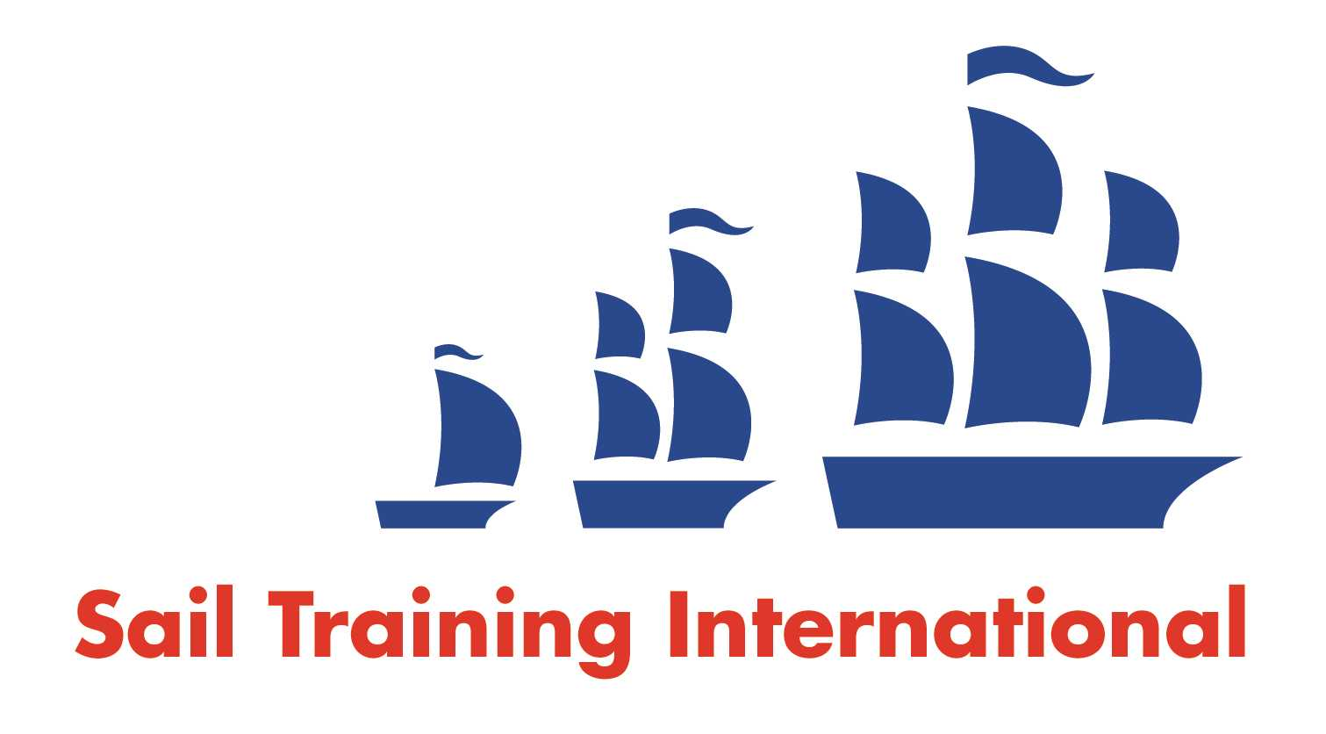
Sail Training International Positions Sought Submission Form

Editorial Policy

- This listing facility is open to any vessel operator or organisation involved in sail training.

- STI reserves the right not to publish a listing for any reason whatsoever.

- After completing the form, email to STI (office@sailtraininginternational.org) for editorial review prior to publishing on site. You can expect your advertisement to appear within 2-3 business days.

- Your listing will be automatically removed after three months unless you indicate an earlier date. To retain a listing beyond three months, please notify STI before the end of the three-month period.

Date of Posting | 16/09/2024
Name | Katie Leathem
Position Sought | Deckhand
Location preference | UK
Seasonal | Paid
Description of Position Sought  (max 100 words) | Deckhand or bosun  working preferably  over the Winter period.
Qualifications | Powerboat 2  Keelboat 2  RYA First Aid  ENG 1  Dayskipper Shorebased  STCWS to be done 25/10/2024
Email | Katie.leathem2006@gmail.com
Telephone | 07562 069 411

