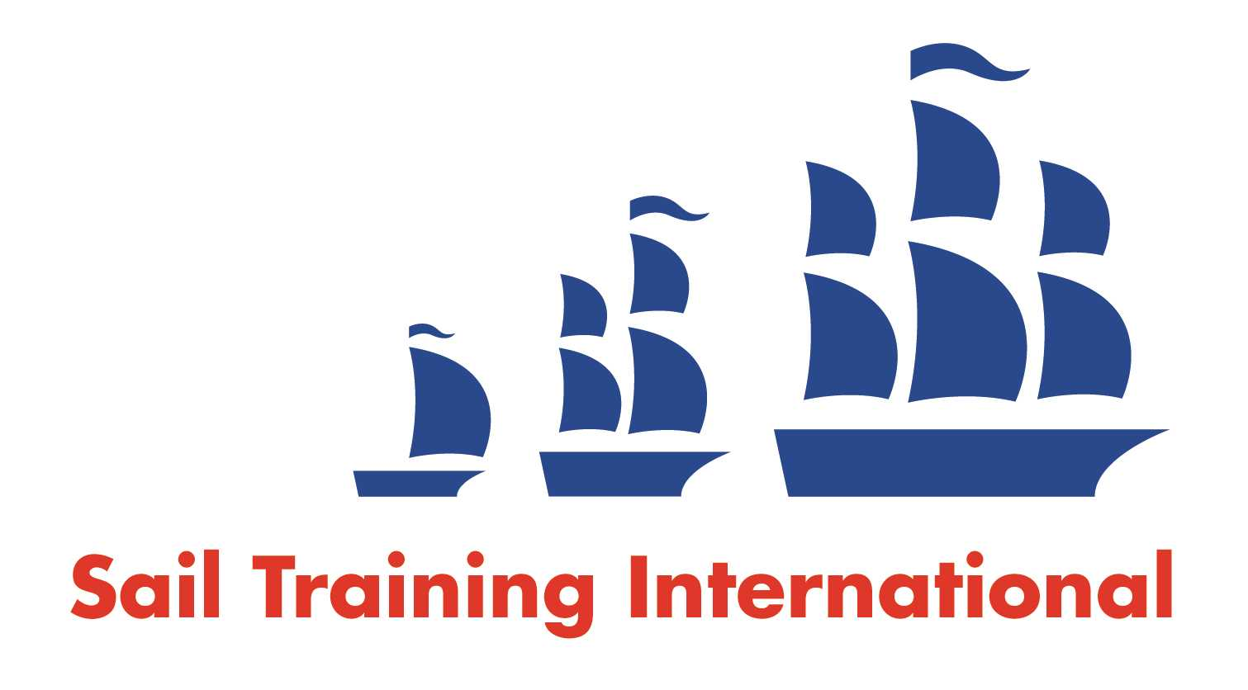
Sail Training International Paid/Volunteer Positions Submission Form

Editorial Policy

- This listing facility is free of charge but will only be accepted from sail training organisations and vessel operators that are members of their national sail training organisation or the Sail Training International Class A Tall Ships Forum.

- STI reserves the right not to publish a listing for any reason whatsoever.

- After completing the form, email to STI (office@sailtraininginternational.org) with copy to your National Sail Training Organisation for editorial review and approval prior to publishing on site.

Date of Posting | 28/08/24
Name of Vessel | Swan LK243
Organisation Recruiting | The Swan Trust
Name of Position | Skipper
Location of Position | Based in Lerwick, Shetland
Position is | Full Time | X | Seasonal
Remuneration | Paid  (delete as appropriate) | £30,000 - £33,000 pro rata  (delete as appropriate)
Description of Position | The Role  The Swan Trust SCIO board of Trustees seek a qualified and experienced Skipper to oversee the operations aboard Swan for the 2025 season – between 1st April and 30th September.  With a focus on community engagement and sail training, this season will include a number of public day and overnight trips, in addition to day taster sessions with Sail Training Shetland and three legs of the Tall Ships Races where sail training experience with young people will be essential.  The Skipper will be responsible for the boat, crew and passenger safety; plotting all courses and liaising with relevant port authorities, harbours and border force agencies as required.  There will be ongoing communication with the Swan Trust office based staff in regard to passenger details, log books and other day to day matters.  The Skipper will be responsible for overseeing all repairs and maintenance, in agreement with Swan Trust Trustees,  with specialist services engaged as required, and minor maintenance being carried out by crew and volunteers.  The Benefits  The renumeration offered is £30,000 – 33,000 per anum, pro rata, depending on experience.  Holiday entitlement shall be 14 days for the six month contract duration.  A bonus scheme based on the performance of the Trust is in operation and, if payable, shall be awarded at the end of the contract period.  The Boat  Swan was originally built in 1900 as a Fifie – a sail herring drifter. At 67 feet she was the largest boat ever built at the Hay’s yard in Lerwick. Following a successful fishing career she was bought and taken to England where she fished intermittently and was used as a houseboat for many years, but ended up being neglected and found many years later in a submerged state in Hartlepool. The boat was returned to Shetland and carefully and fully restored by a group of enthusiastic experts in the 1990s and launched a new career as a sail training vessel from 1996.  Swan sails with a gaff ketch rig and has a 4 stroke Cummings engine.  She has 15 berths, which allows for a minimum of 3 crew at all times, with 12 passengers – or on overnight trips, 5 crew and 10 passengers to accommodate watch shifts. The Swan Trust SCIO engage a number of volunteer crew, with a paid Skipper and Mate post on board.  The Requirements  The following qualifications and certifications are required as a minimum for this role:  - RYA Yachtmaster Offshore Commercially Endorsed Certificate, or MCA accepted equivalent or higher qualification  - Radio Operator’s certificate, suitable for the radio equipment on board  - Medical Fitness Certificate, ENG1 (valid 2 years)  - Basic Sea Survival Course.  - First Aid Training. The skipper should hold as a minimum, a Proficiency in Medical Care Certificate, or its predecessor, Ship’s Captain’s Medical Certificate. It would be an advantage to hold an MCA approved Elementary First Aid Certificate, or the First Aid at Sea Certificate, or Medical First Aid Certificate; an RYA First Aid Certificate, or a SeaFish Basic First Aid Certificate, provided use of the medical stores carried is covered in the course.  - Radar training  - Approved engine course (or certified engineer)  - Stability Guidance Booklet Familiarisation  The following qualifications and training or experience would be an advantage to any application:  - Fire safety training  - Elementary Food Hygiene Course  Additional  From April 2025, all staff and volunteers working with Vulnerable Groups will be required to undergo a PVG (Protection of Vulnerable Groups) check for the organisation they work with.  The appointed Skipper will be checked and registered with the Swan Trust SCIO as an employer. This will be at the Trust’s expense. Failure to pass this check or comply with the application will void any appointment to this role.  To apply:  Please apply in writing to:  The Swan Trust SCIO, Board of Trustees  16 Alexandra Building, Lerwick, Shetland, ZE2 0LL  Or  info@swantrust.com  Your application letter should explain why you are applying for the role, confirm your availability for the full 2025 season and detail all relevant qualifications, certifications and experience for this role. It is acceptable to submit a CV along with the cover letter.  Two references should be provided with your application, or details of two individuals that you are happy for the Trust to contact during the application process.  The closing date for applications is Friday 20th September.
Person to Contact | Emma Miller
Organisation’s website: | www.swantrust.com
Email | info@swantrust.com
Telephone | 07753806095
Fax
Closing Date for applications | 20/09/24

