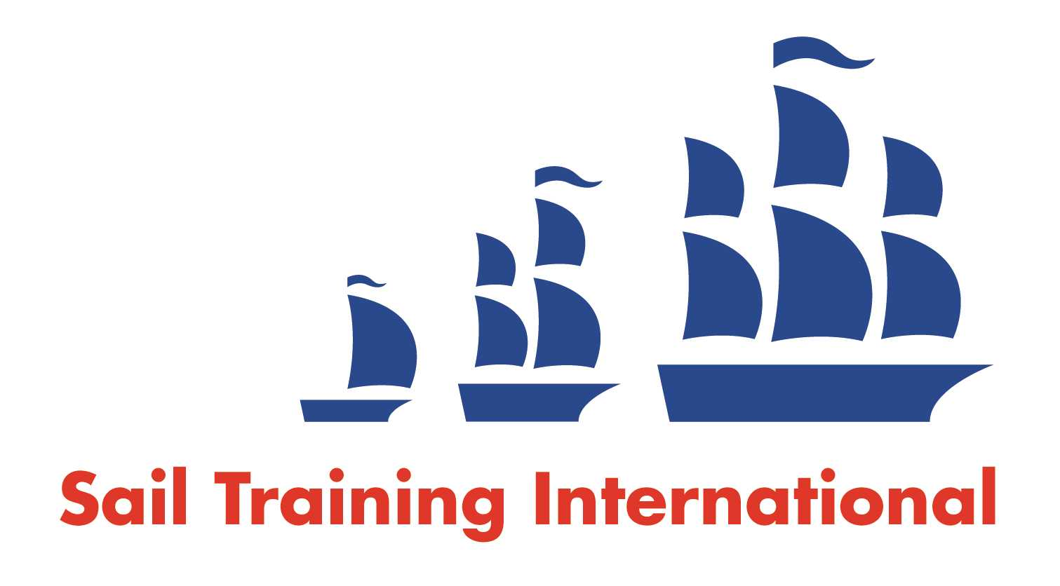
Sail Training International Paid/Volunteer Positions Submission Form

Editorial Policy

- This listing facility is free of charge but will only be accepted from sail training organisations and vessel operators that are members of their national sail training organisation or the Sail Training International Class A Tall Ships Forum.

- STI reserves the right not to publish a listing for any reason whatsoever.

- After completing the form, email to STI (office@sailtraininginternational.org) with copy to your National Sail Training Organisation for editorial review and approval prior to publishing on site.

Date of Posting | 09.09.24
Name of Vessel | Blue Clipper
Organisation Recruiting | Maybe Sailing Ltd
Name of Position | Refit volunteer
Location of Position | Portimão, Portugal
Position is | Full Time |  | Seasonal | x
Remuneration | Voluntary  (delete as appropriate) | (delete as appropriate)
Description of Position | Refit volunteers required for help with sanding, painting, sail repair, general maintenance.
Person to Contact | Gette Nichols
Organisation’s website: | www.maybe-sailing.com
Email | info@maybe-sailing.com
Telephone | 01133919809
Fax
Closing Date for applications | 30.09.24

