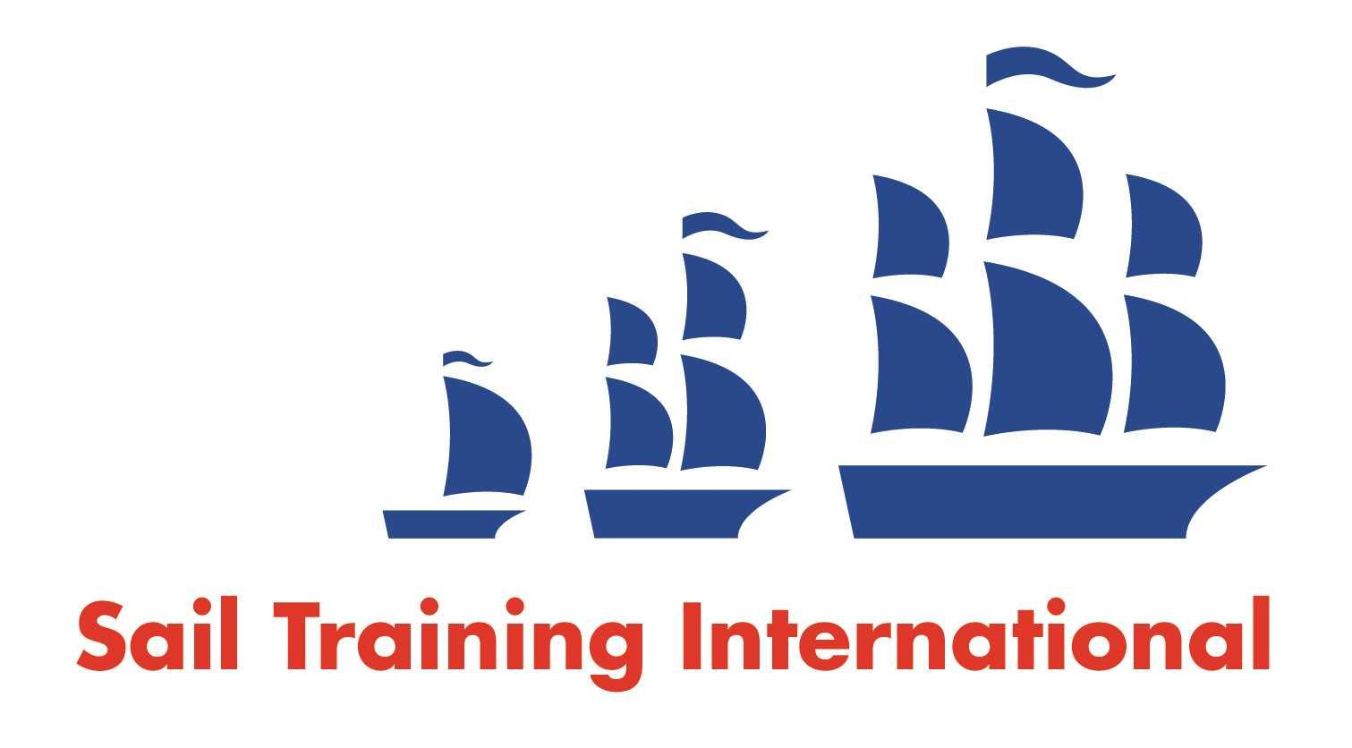
Sail Training International Positions Sought Submission Form

Editorial Policy

- This listing facility is open to any vessel operator or organisation involved in sail training.

- STI reserves the right not to publish a listing for any reason whatsoever.

- After completing the form, email to STI (office@sailtraininginternational.org) for editorial review prior to publishing on site. You can expect your advertisement to appear within 2-3 business days.

- Your listing will be automatically removed after three months unless you indicate an earlier date. To retain a listing beyond three months, please notify STI before the end of the three month period.

Date of Posting | December 6th, 2023
Name | Kate Smith
Position Sought | Deckhand/Educator/Research Assistant
Location preference | Worldwide
Full Time / Seasonal  full time preferred but open to both |  | Paid / Voluntary  Paid
Description of Position Sought  (max 100 words) | Looking to crew as a deckhand, educator, or research assistant.
Qualifications | I spent two years aboard Bluenose II as a deckhand.  I have received my: STCW, MED-DVS, Marine First Aid, VHF Operators certification, and IYT Crew certification.  I also am graduating with a BSc in Marine Biology from Memorial University of Newfoundland in June 2024.  I have sailed/taught sailing since age 8 and completed an Atlanitc crossing in 2020.
Email | kateangelicas01@gmail.com
Telephone | +1(902)217-6232

