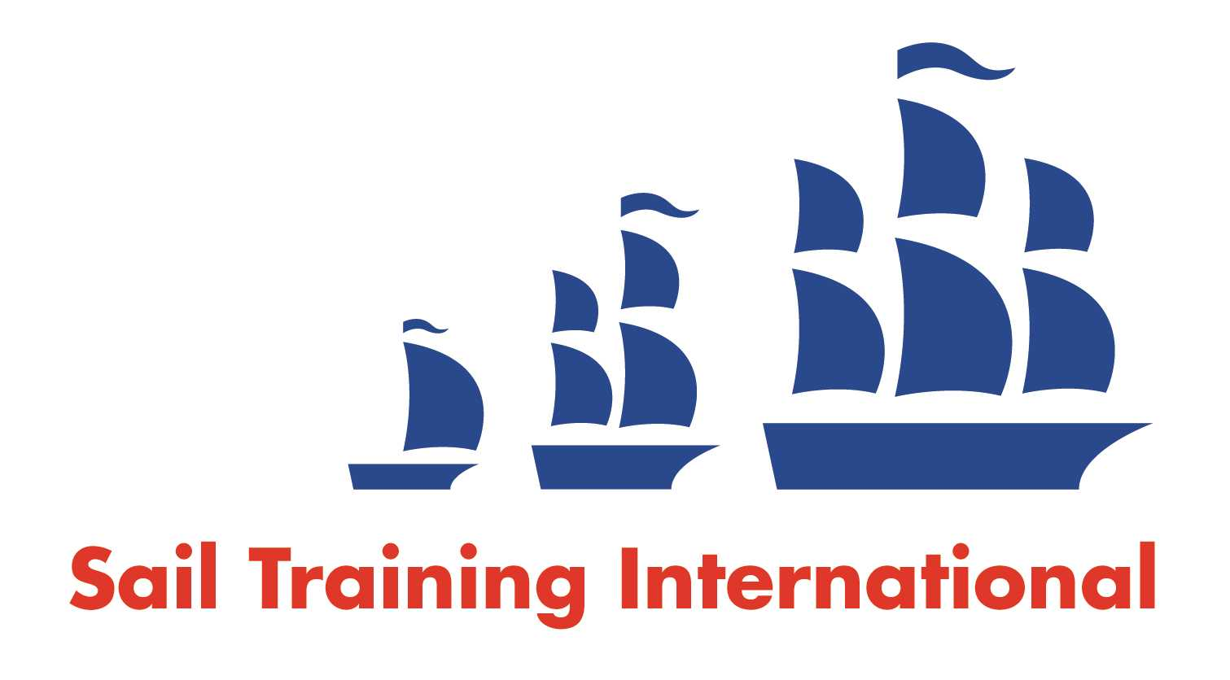
Sail Training International Paid/Volunteer Positions Submission Form

Editorial Policy

- This listing facility is free of charge but will only be accepted from sail training organisations and vessel operators that are members of their national sail training organisation or the Sail Training International Class A Tall Ships Forum.

- STI reserves the right not to publish a listing for any reason whatsoever.

- After completing the form, email to STI (office@sailtraininginternational.org) with copy to your National Sail Training Organisation for editorial review and approval prior to publishing on site.

Date of Posting | 19/12/23
Name of Vessel | Queen Galadriel, Faramir, Duet
Organisation Recruiting | The Cirdan Sailing Trust
Name of Position | 1st Mate
Location of Position | UK
Position is | Full Time |  | Seasonal | Y
Remuneration | Paid | £25,000pa pro rata
Description of Position | The Cirdan Sailing Trust is looking for an experienced First Mate to work across our fleet of traditional sailing vessels.  The Cirdan Sailing Trust conducts sail training voyages for disadvantaged young people from a broad spectrum of backgrounds. Due to this we are seeking a candidate with the motivation and energy to work with young people to develop their independence, resilience and confidence.  Our fleet generally operate around the coast of the UK although occasionally venture further afield.  As First Mate, you will assist the Skipper in the delivery of voyages and help ensure the smooth operation of the vessel.  The contract for the successful candidate will begin in February 2024 until November 2024. This may be negotiable for the right candidate.  Requirements  Yachtmaster Offshore with Commercial Endorsement  RYA Level 2 Powerboat  ENG1 Medical Certificate  Experience of traditional / large sailing vessels  Experience of working with young people (not necessarily in a sailing capacity)  Experience of vessel maintenance  A desire to help and develop junior members of crew and volunteers  All applicants must have, or be able to obtain, an Enhanced DBS and must have the right to live and work in the UK.
Person to Contact | Ed
Organisation’s website: | www.cirdantrust.org
Email | ed@cirdantrust.org
Telephone | 01621 776684
Fax
Closing Date for applications | Until Filled

