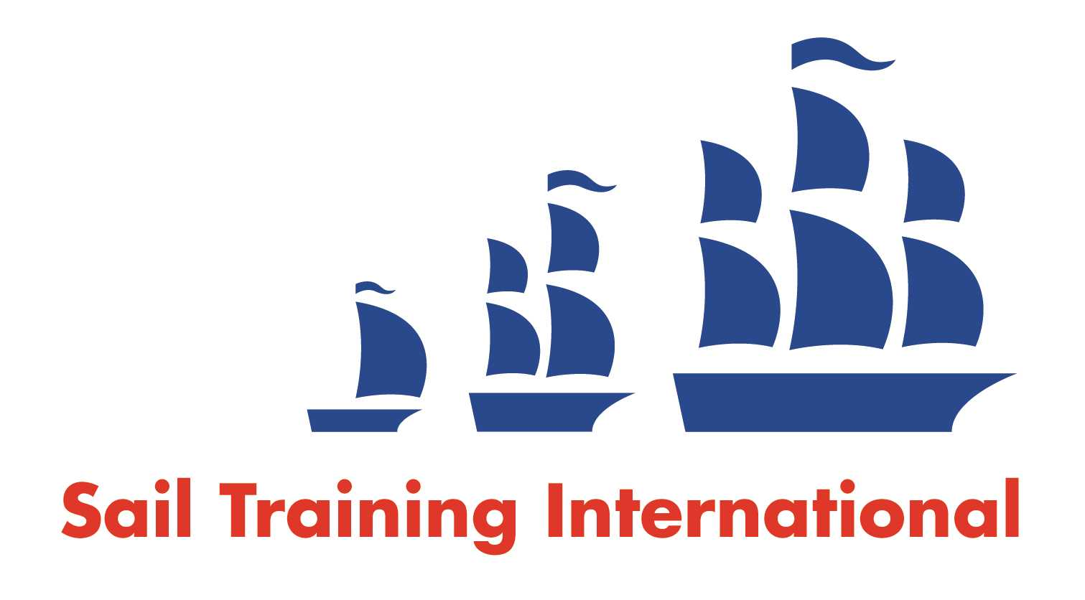
Sail Training International Positions Sought Submission Form

Editorial Policy

- This listing facility is open to any vessel operator or organisation involved in sail training.

- STI reserves the right not to publish a listing for any reason whatsoever.

- After completing the form, email to STI (office@sailtraininginternational.org) for editorial review prior to publishing on site. You can expect your advertisement to appear within 2-3 business days.

- Your listing will be automatically removed after three months unless you indicate an earlier date. To retain a listing beyond three months, please notify STI before the end of the three month period.

Date of Posting | 25/10/23
Name | Daniel Charles
Position Sought | Engineer
Location preference | Europe
Seasonal |  | Paid
Description of Position Sought  (max 100 words) | Engineer  Qualified fishing vessel engineer with an ability to work on deck as well, previous tall ship experience as well as commercial boat skippering.  All-rounder able to intuitively tackle any technical situation.
Qualifications | STCW Basic training  STCW 3 Day Firefighting  GMDSS SRC COC  ISA Coastal Navigation for Small boats  ISA Advanced Powerboat Certificate  ISA Level 5 Advanced Boat Handling (sailing)  BIM Deckhand Programme cert  QQI LVL 5 Fishing Vessel Engineering
Email | danielwalsh1006@gmail.com
Telephone

