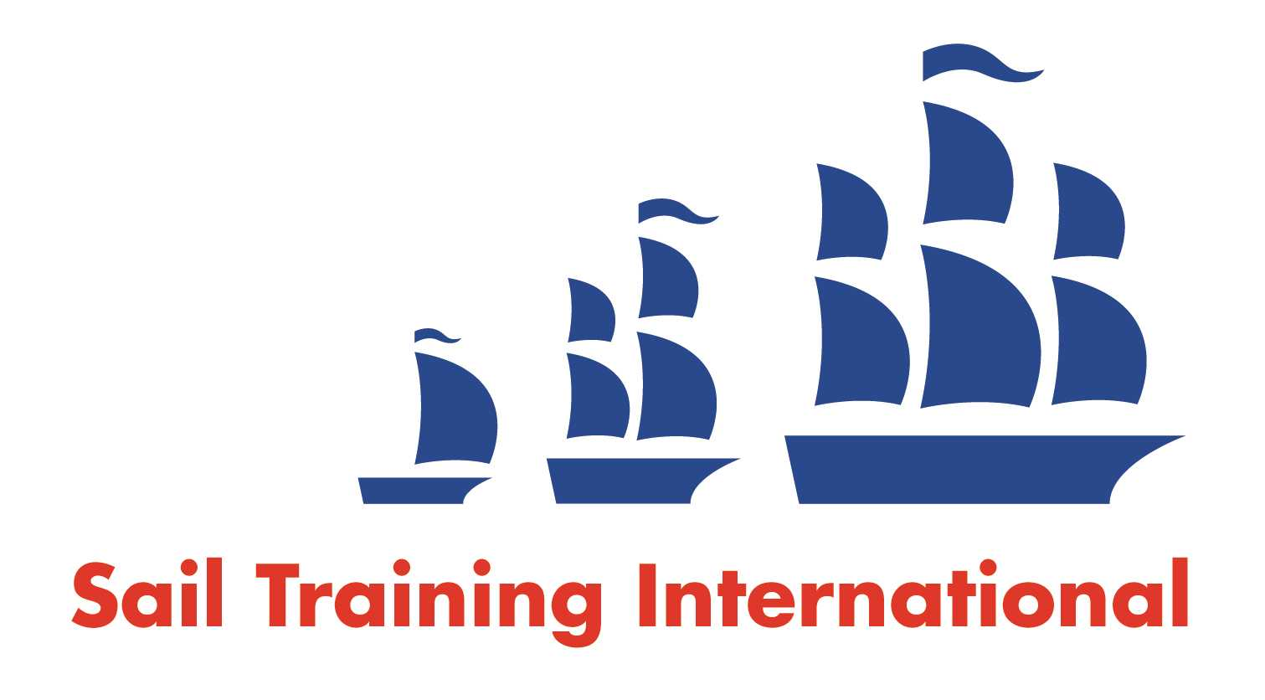
Sail Training International Paid/Volunteer Positions Submission Form

Editorial Policy

- This listing facility is free of charge but will only be accepted from sail training organisations and vessel operators that are members of their national sail training organisation or the Sail Training International Class A Tall Ships Forum.

- STI reserves the right not to publish a listing for any reason whatsoever.

- After completing the form, email to STI (office@sailtraininginternational.org) with copy to your National Sail Training Organisation for editorial review and approval prior to publishing on site.

Date of Posting | 1st August 2023
Name of Vessel | Challenge Wales
Organisation Recruiting | Challenge Wales
Name of Position | Freelance Skipper (Short term / immediate opportunity)
Location of Position | Join Falmouth – Depart ACoruna
Position is | Full Time |  | Seasonal | X
Remuneration | Paid  (delete as appropriate) | £140 - £170 per day depending on experience + travel expenses  (delete as appropriate)
Description of Position | Challenge Wales is looking for a Commercially Endorsed Yachtmaster Ocean, available immediately for the Tall Ships Races (Falmouth to Acoruna).  Supported by our onboard Staff Skipper and crew, you will need to join the boat by 17th August and depart the boat in Acoruna on 26th August.  Guests onboard will be aged 16 – 25 years for this leg.  Tasks & Responsibilities  You will be involved with:  • Leading a team supported by a Challenge Wales staff Skipper  *Working with young people and crew from diverse backgrounds  • Manage all aspects of the assigned vessels operation  • Able to be professional and commercially & personally sensitive at all times (both on and off the vessel) acting with tact and diplomacy  • Manage safety, discipline, morale and welfare of volunteers, trainees and clients  • Victualling the vessel within budget and following Challenge Wales’ financial and purchasing procedures  • dealing with unexpected and planned issues which might be encountered on a sailing vessel at sea, e.g. repairs, maintenance, electrical (AC & DC), plumbing systems/bilge systems, generator, diesel engine, sail repairs  - Being part of the crew parade with the Challenge Wales Team  • Championing the brand and vision and raising the profile of the Challenge Wales charity  The successful candidate will need a valid ENG1, a DBS which Challenge Wales can organise free of charge for you, provide 2 references and undertake a short free, online safeguarding course.
Person to Contact | Vicky Williams
Organisation’s website: | www.challengewales.org
Email | vicky@challengewales.org
Telephone | 02920 704657
Fax
Closing Date for applications | Due to the timeframe we suggest those interested in applying contacting Vicky Williams asap

