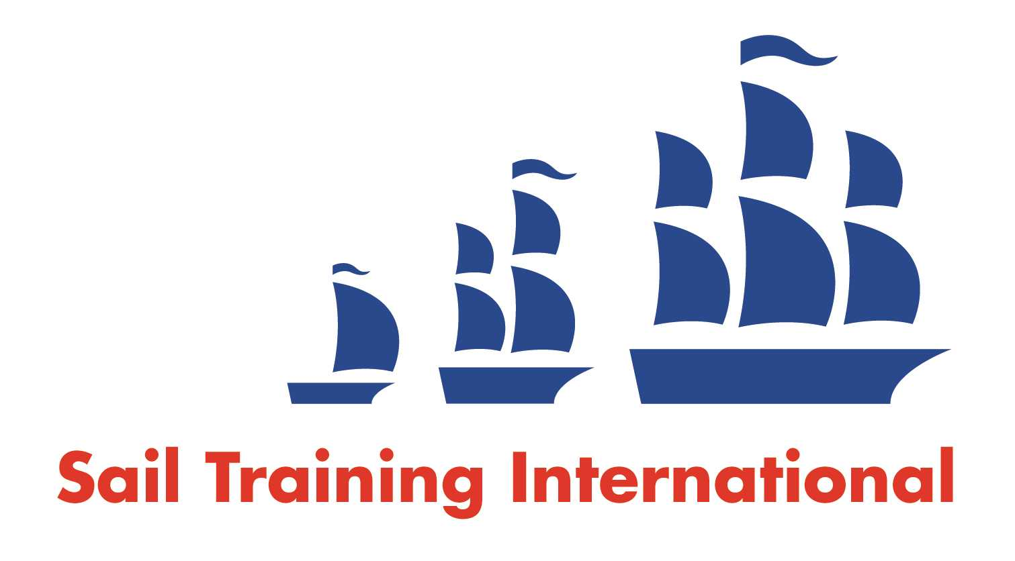
Sail Training International Paid/Volunteer Positions Submission Form

Editorial Policy

- This listing facility is free of charge but will only be accepted from sail training organisations and vessel operators that are members of their national sail training organisation or the Sail Training International Class A Tall Ships Forum.

- STI reserves the right not to publish a listing for any reason whatsoever.

- After completing the form, email to STI (office@sailtraininginternational.org) with copy to your National Sail Training Organisation for editorial review and approval prior to publishing on site.

Date of Posting | 04.07.2023
Name of Vessel | Eye of the Wind
Organisation Recruiting | FORUM train & sail GmbH, Germany
Name of Position | First Mate (m / f)
Location of Position | Worldwide
Position is | Full Time | x | Seasonal
Remuneration | Paid | € - TBD
Description of Position | We are seeking an ocean going, 200 GT or above qualified mate, preferably with a background in sail training. Familiarity with traditional ships, including extensive square rig experience, is essential. Applicants should be energetic, and able to fit comfortably into a young, international team of people with varying levels of experience.  Your responsibilities include standing navigational watches, maintenance of safety and navigation equipment, medical kit, as well as active participation on deck in all activities and maneuvers in the operation of the ship. This includes coordinating the operation and maintenance of all components of the rigging as well as general ship maintenance; in addition, also the care of the maximum 12 guests, and overseeing and supporting interior stewardship.  You will work in an on/off system of approx. three months on board / three months off (1:1 rotation).  Requirements:  You have a valid STCW Basic Safety Certificate and a valid ENG 1 seafarer medical fitness certificate, in addition to ocean going 200 GT or above qualification. You act responsibly, in a service-oriented and friendly manner. In addition, you have the necessary physical requirements to work as a sailor on board a seagoing vessel. An extensive experience of sailing and maintaining square-rigged sailing vessels is required, and you can competently convey your expertise to our crew. Good English or German language skills are required for communication with staff and guests.  As a charter vessel, the Eye of the Wind is operating in appealing areas, with an international on-board crew of 10. A prerequisite for a permanent employment contract is your willingness to get to know your workplace and our crew members during a trial week on board. Have we piqued your interest? We look forward to receiving your application with CV and certificates at info@eyeofthewind.net
Person to Contact | Captain: Megan Watt, Moritz Hannoschöck, Marc Kunze  Office: Julia Nieborowsky
Organisation’s website: | www.eyeofthewind.net
Email | info@eyeofthewind.net
Telephone | +49 8233 / 381 - 227
Fax | -
Closing Date for applications | until filled

