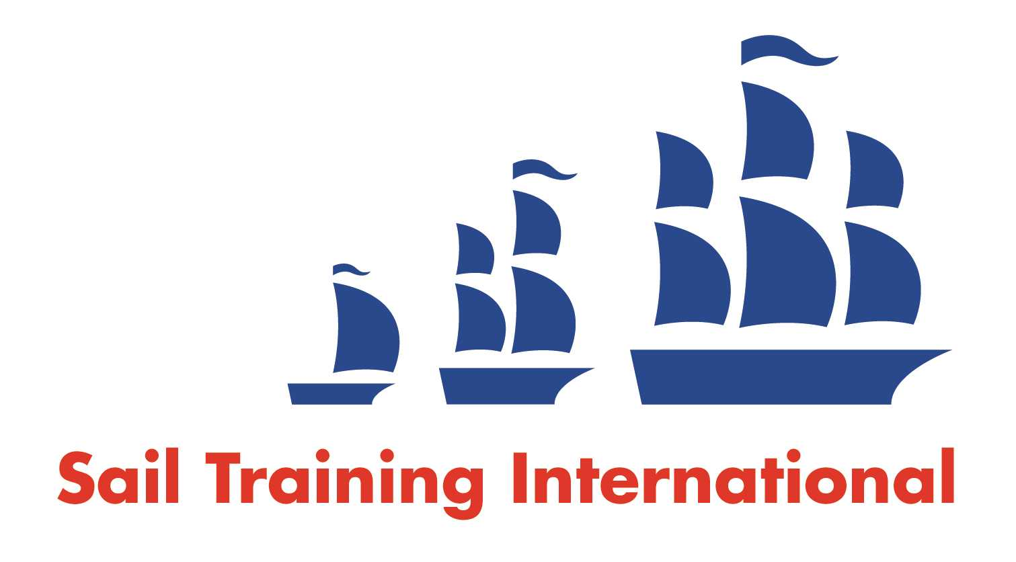
Sail Training International Paid/Volunteer Positions Submission Form

Editorial Policy

- This listing facility is free of charge but will only be accepted from sail training organisations and vessel operators that are members of their national sail training organisation or the Sail Training International Class A Tall Ships Forum.

- STI reserves the right not to publish a listing for any reason whatsoever.

- After completing the form, email to STI (office@sailtraininginternational.org) with copy to your National Sail Training Organisation for editorial review and approval prior to publishing on site.

Date of Posting | 27.07.23
Name of Vessel | Thermopylae Clipper, Discovery DSP
Organisation Recruiting | Discovery Sailing Project
Name of Position | Project Organiser
Location of Position | Universal Marina, Hamble / Working from home
Position is | Part time/all year round |  | Seasonal
Remuneration | Paid | £20 per hour
Description of Position | Job Description | Project Organiser  About Discovery Sailing Project  Discovery Sailing Project http://www.dsp.uk.com is a Sail Training Charity which is part of the Scout Association. We enable young people from all walks of life to experience and benefit from Offshore Sailing. We operate three yachts from our base: DSP HQ, Universal Marina, on the River Hamble:  - Thermopylae Clipper, 60’, 15 berths  - Discovery DSP, 43’, 12 berths  - Alexander Fairey, 34’, 8 berths  About the Role:  This a part time role, 20 hours/week, working both from DSP HQ and from home. Reporting to the Lead Volunteer and supported by the Lead Volunteer, Chair of the Trustee Board, Bosun, Treasurer and Training Officer, you will be working with a passionate and dedicated team of Volunteers from 14 years old and above. The Project Organiser is the lead for day-to-day operations of the DSP, operating three boats, ensuring they go to sea safely, within a predominantly Volunteer driven organisation. Growing and maintaining the relationships of the DSP with our Customers, Volunteers, Governing Organisations and Suppliers is essential. The Project Organiser also acts as Principal of the Discovery Sailing Project RYA training centre and is the responsible person named on each boats’ coding certificate, ensuring the boats all remain “in code”.  The Project Organiser is also encouraged to sail as a Volunteer with the Project. This is a unique, exciting, engaging and fulfilling role where the main requirement is to ensure that young people get to partake in a lifechanging experience through the power of Sail Training.  Skills & Attributes:  Essential  - Demonstrate an outstanding passion and aptitude for Sail Training and youth development  - Personable, approachable and enthusiastic  - Extremely well organised, excellent time management, self-motivated and adaptable  - Excellent relationship building, diplomacy, networking and communication skills, both written and verbal  - Customer and stakeholder liaison experience  - Computer literate with fluency in Microsoft including: advanced email usage e.g.  - Online Forms, Word, Excel and PowerPoint, QuickBooks and Social Media Facebook, Instagram, LinkedIn, Twitter, etc.  Desirable  - Fundraising, bid writing, grant funding application submission, making applications for donations • RYA sailing qualifications (Ideally YM Offshore)  - Knowledge and experience of Sail Training  - Knowledge and experience of The Scout Association  - Experience working with adult and youth volunteers
Person to Contact | David Wallder
Organisation’s website: | www.dsp.uk.com
Email | David.wallder@dsp.uk.com
Telephone | +44 (0)1489 580099
Fax | n/a
Closing Date for applications | 20.08.23

