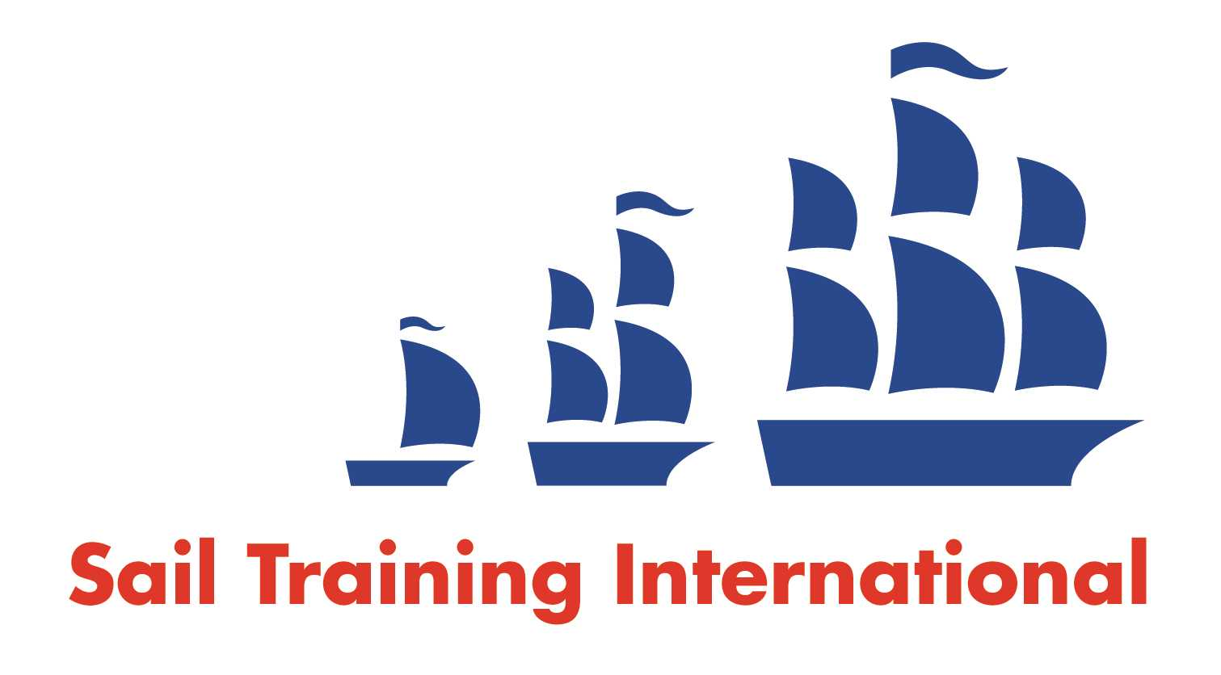
Sail Training International Paid/Volunteer Positions Submission Form

Editorial Policy

- This listing facility is free of charge but will only be accepted from sail training organisations and vessel operators that are members of their national sail training organisation or the Sail Training International Class A Tall Ships Forum.

- STI reserves the right not to publish a listing for any reason whatsoever.

- After completing the form, email to STI (office@sailtraininginternational.org) with copy to your National Sail Training Organisation for editorial review and approval prior to publishing on site.

Date of Posting | 06/07/2023
Name of Vessel | Spirit of Outward Bound Hong Kong
Organisation Recruiting | Outward Bound Hong Kong
Name of Position | Skipper
Location of Position | Hong Kong
Position is | Full Time | x | Seasonal
Remuneration | Paid | HKD $25,000 – HKD$32,000 / month
Description of Position | Amazing opportunity to Skipper 20m sail training yacht in Hong Kong. Full contract with leave, benefits and accommodation. Unique sailing program including racing, offshore expedition, youth development work and training. All candidates must bring enthusiasm, patience, compassion and flexibility to the role.  https://www.linkedin.com/jobs/view/3646897383
Person to Contact | Amelia Ralphs
Organisation’s website: | https://www.outwardbound.org.hk
Email | ameliaralphs@outwardbound.org.hk
Telephone | +852 61326371
Fax
Closing Date for applications | 05/09/2023

