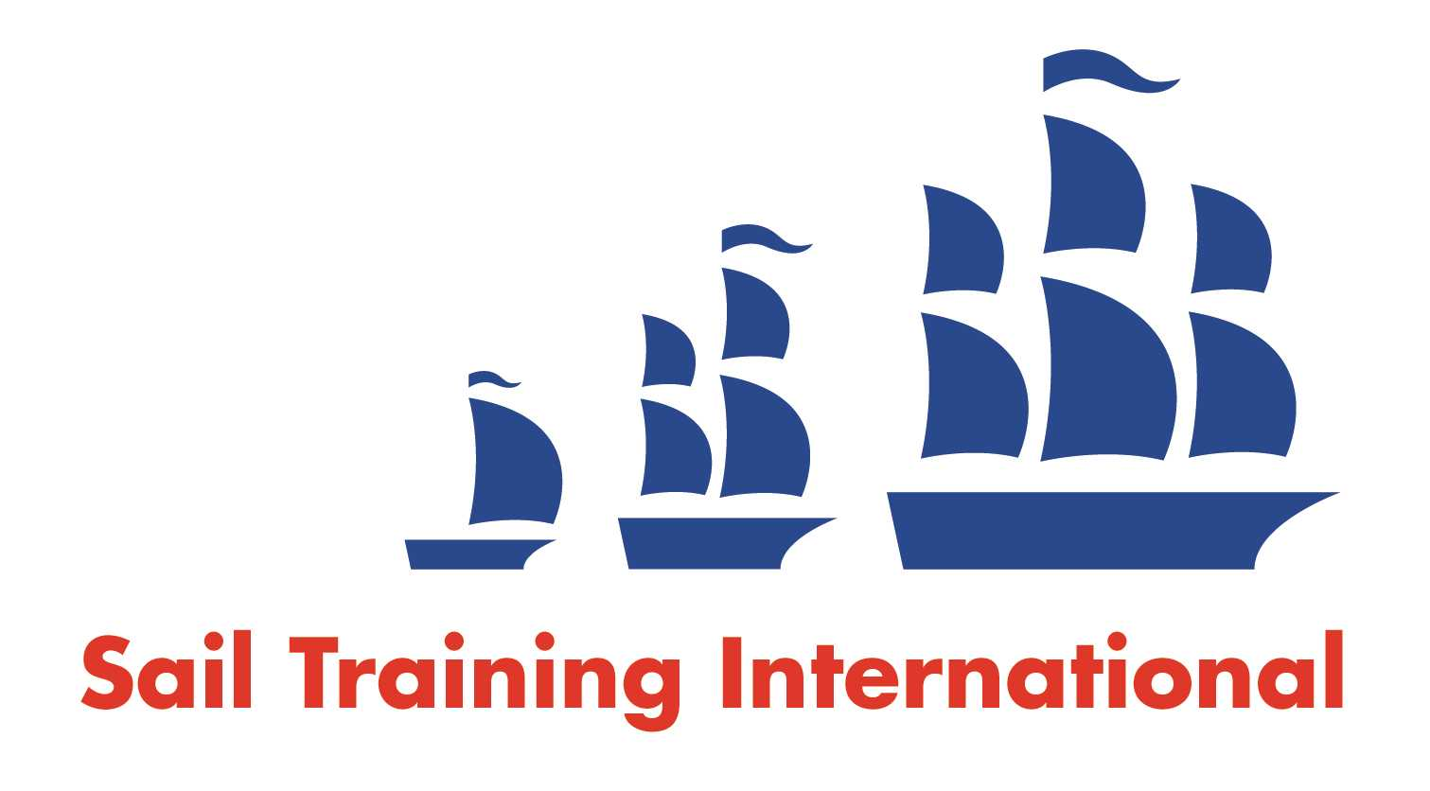
Sail Training International Paid/Volunteer Positions Submission Form

Editorial Policy

- This listing facility is free of charge but will only be accepted from sail training organisations and vessel operators that are members of their national sail training organisation or the Sail Training International Class A Tall Ships Forum.

- STI reserves the right not to publish a listing for any reason whatsoever.

- After completing the form, email to STI (office@sailtraininginternational.org) with copy to your National Sail Training Organisation for editorial review and approval prior to publishing on site.

Date of Posting | 30/06/2023
Name of Vessel | Port Edgar Marina
Organisation Recruiting | Marine Society and Sea Cadets
Name of Position | Chief Instructor
Location of Position | Port Edgar Marina, Shore Road, South Queensferry, Edinburgh, EH30 9SQ
Position is | Full Time | X | Seasonal
Remuneration | Paid | £27,250 gross per annum
Description of Position | We are looking for an inspirational Chief Instructor to lead our afloat activities programme at our Port Edgar Boat Station. As chief instructor you will develop and deliver activities across sailing, powerboating, windsurfing, paddle sports and rowing to cadet and adult members of the Sea Cadets. You will be responsible for managing a team of volunteers, casual instructors and cadet instructors to deliver a full programme of activities throughout the year, promoting positive, life changing experiences on the water.
Person to Contact | Adam Ranklin
Organisation’s website: | Chief Instructor - Port Edgar - MSSC (workable.com)
Email
Telephone
Fax
Closing Date for applications | 28/07/2023

