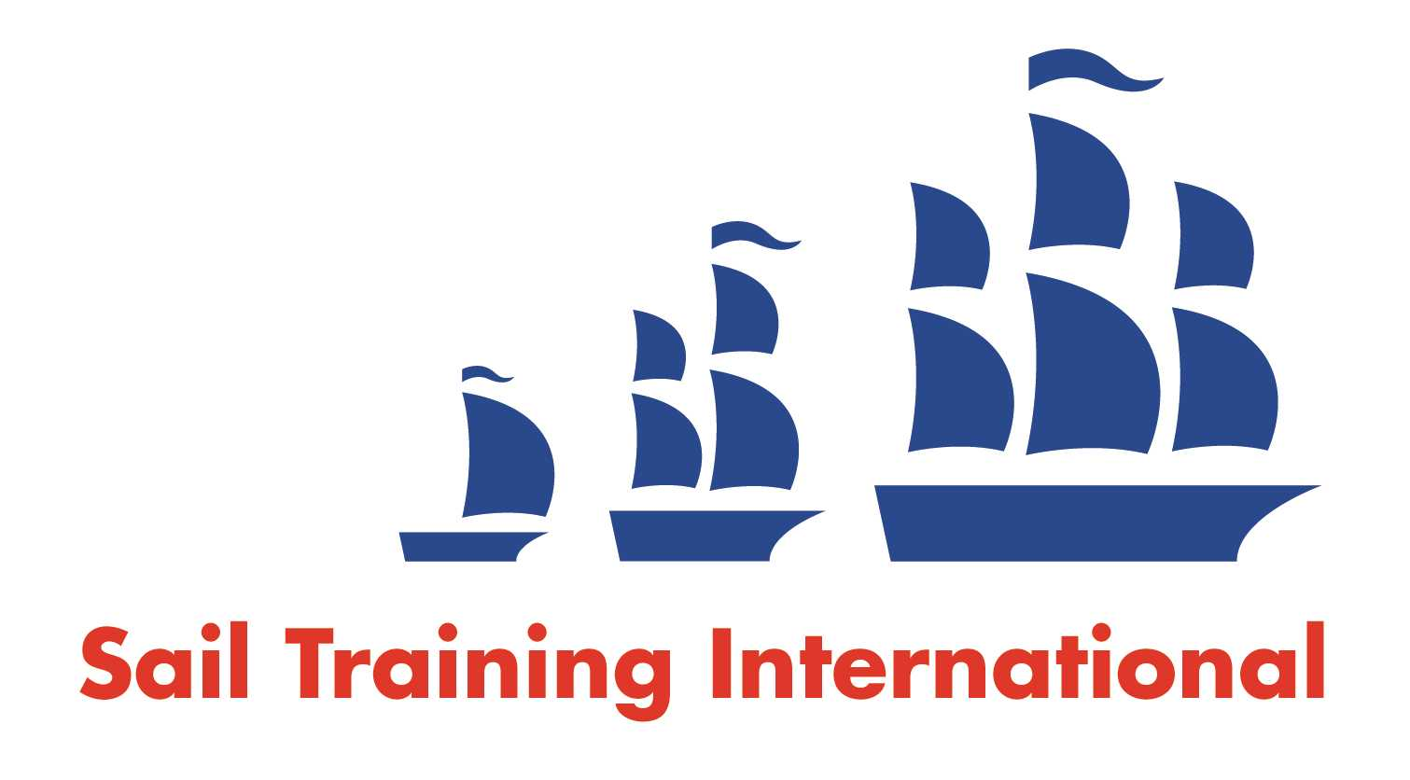
Sail Training International Paid/Volunteer Positions Submission Form

Editorial Policy

- This listing facility is free of charge but will only be accepted from sail training organisations and vessel operators that are members of their national sail training organisation or the Sail Training International Class A Tall Ships Forum.

- STI reserves the right not to publish a listing for any reason whatsoever.

- After completing the form, email to STI (office@sailtraininginternational.org) with copy to your National Sail Training Organisation for editorial review and approval prior to publishing on site.

Date of Posting | 2nd June 2023
Name of Vessel | Prolific
Organisation Recruiting | Ocean Youth Trust South
Name of Position | Refit Volunteers
Location of Position | Southampton
Position is | Full Time |  | Seasonal | Yes
Remuneration | Voluntary | n/a
Description of Position | Ocean Youth Trust South will be carrying out a refit to our vessel Prolific (https://www.oytsouth.org/our-vessel-prolific/) from November 2023 to March 2024. The charity recruits refit volunteers aged 18+ who can join us for a few weeks or the full four months, for a chance to develop boat maintenance skills in exchange for food and accommodation.  Previous boat maintenance or other practical experience is an advantage but not essential: we are looking for people who can be reliable, enthusiastic and hard-working team members. Many refit volunteers have gone on to sail with the charity as volunteer watchleaders, bosuns or relief engineers in the following season. A place on the core team is worth considering if you are between jobs or on a gap year or have recently left school, college or university (but places are also open to older volunteers). It could be ideal for someone considering a career in the marine industry, especially if you already have sailing skills but need to be able to show potential employers that you have experience in fixing things on board if needed! It is also suitable for anyone who likes the idea of contributing to a good charitable cause and spending time on a fun, exciting project.  If you are interested in applying for the core team, or you just want us to contact you for a chat about what's involved, please send in the information requested at the bottom of this webpage: https://www.oytsouth.org/refit-team/.  Please note that while we will arrange accommodation in the Southampton area for our refit team (either living on board or ashore), we will not necessarily be able to offer accommodation during all weekends and holidays, so we will not be able to consider overseas applicants who do not have anywhere else to stay in the UK.
Person to Contact | Caroline White
Organisation’s website: | www.oytsouth.org
Email | refit@oytsouth.org
Telephone | 02392 602278
Fax | n/a
Closing Date for applications | February 2024

