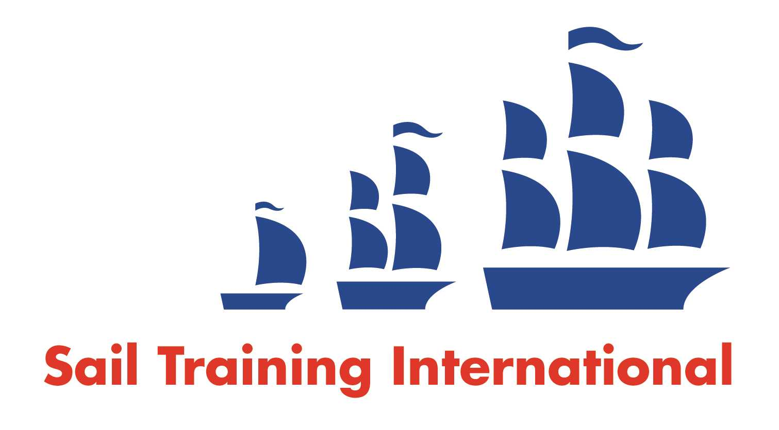

**Sail Training International Paid/Volunteer Positions Submission Form**

**Editorial Policy**

1. This listing facility is free of charge but will only be accepted from sail training organisations and vessel operators that are members of their national sail training organisation or the Sail Training International Class A Tall Ships Forum.
2. STI reserves the right not to publish a listing for any reason whatsoever.

1. After completing the form, email to **STI** ([office@sailtraininginternational.org](mailto:office@sailtraininginternational.org)) with copy to your **National Sail Training Organisation** for editorial review and approval prior to publishing on site.

|  |  |  |  |  |
| --- | --- | --- | --- | --- |
| **Date of Posting** | 8 Jun 2023 | | | |
| **Name of Vessel** | TS Royalist | | | |
| **Organisation Recruiting** | Marine Society and Sea Cadets | | | |
| **Name of Position** | Commanding Officer | | | |
| **Location of Position** | Operating from Gosport, Hampshire, UK | | | |
| **Position is** | **Full Time** |  |  |  |
| **Remuneration** | **Paid**  (delete as appropriate) | **€/$/£ Competitive**  (delete as appropriate) | | |
| **Description of Position** | TS Royalist acts as the Flagship for the Marine Society and Sea Cadets. The key responsibilities and tasks of the Commanding Officer are to be responsible for all activity onboard the vessel, deliver a varied and exciting Sea Cadet experience, and promote the work of the MSSC and the Sea Cadet Corps.  Applicants should have the requisite square-rig sailing experience, including time in command, and hold an Offshore Yachtmaster (Sail) qualification, commercially endorsed, or Merchant Navy equivalent. They should also either hold or be capable of holding a current Seafarer Medical Certificate. The ability to work effectively with young people as well as the permanent and relief crew members is essential. Ship system familiarisation, child safeguarding and any necessary sea safety course refresher training will be given to the successful applicant.  The particular demands of seagoing employment require the incumbent to be available for duty for prolonged periods and working hours necessarily need to be very flexible. Although overtime will not be recognised, the working and rest hours for this role will be within the confines of the terms of the Maritime Labour Convention 2006. The uncertain nature of the working hours are recognised by the holiday arrangements afforded.  Responsibilities   * Command the 35m TS Royalist and all personnel embarked on board. * Deliver life-changing 6-day voyages around the UK and near continent for 24 young people per week. * Ensure the mandated crewing of vessels are maintain working with the support office to manage, appraise, permanent and relief crew, agree leave patterns and educate understudy personnel to maintain an appropriately trained relief crew(s). * Safe navigation of the vessel. * Execute the directed programme, delivering interesting, innovative and fun weekly voyages for embarked cadets. * Stand deck watches 1-in-2 with Sailing Master when at sea. * Responsible for the safety, discipline, morale, welfare and day-to-day employment of permanent crew members and embarked personnel. * Advise on Merchant Shipping Regulations and other statutory regulations in so far as they apply to TS ROYALIST. * Oversee the onboard Planned Maintenance through use of an electronic system.   Requirements   * Yachtmaster Offshore (Sail) with commercial endorsement (or Merchant Navy equivalent CofC). * Ship-handling experience to command a 35m square-rigged Brig. * Ability to interact effectively with a wide range of personnel from young cadet to visiting VIPs. * Strong management and leadership skills and ability to direct ships staff with clarity and in a positive manner. * Ability to hold and maintain an Offshore Medical Certificate (ENG1).   Desirable   * Ability to manage onboard team of permanent and relief staff. * Ability to perform effectively when under pressure, meet deadlines and make clear and safe decisions. * Computer literate – good working knowledge of Microsoft Office products.   For further information, please download the .  Benefits   * 104 days annual leave per annum (84 days during the sailing season, 20 working days during winter months). * Life assurance (4x salary) for those that join the pension. * Private medical insurance. * Pension (employer contribution up to 10%). * Wellbeing portal and EAP with 121 counselling.   Employee development: We are investing in our employees' development and have an annual calendar of learning and development opportunities, designed to support employees to develop into their roles and stretch them to achieve their full potential.  National staff conference: All employees come together once a year to reflect on the past year and celebrate success at our offsite staff conference. This is a great opportunity to listen to employees' views, and for employees to network, share information and socialise.  If you are interested in becoming the next Commanding Officer of TS Royalist, please apply now! | | | |
| **Person to Contact** | Cdr (Retd) M Middleton | | | |
| **Organisation’s website:** | Apply via [Commanding Officer Training Ship Royalist | MSSC | Jobs By Workable](https://jobs.workable.com/view/6sGMtrFVCzxTArMDkHswqK/commanding-officer-training-ship-royalist-in-gosport-at-mssc) | | | |
| **Email** | MMiddleton@MS-SC.org | | | |
| **Telephone** | 07798675147 | | | |
| **Fax** |  | | | |
| **Closing Date for applications** | 1 Jul 2023 | | | |