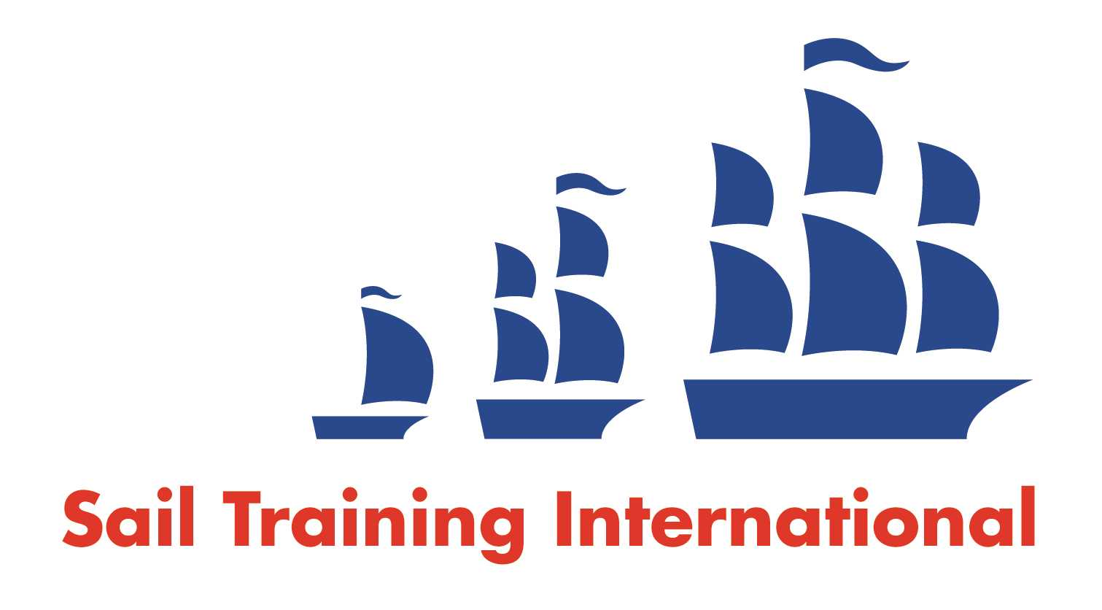
Sail Training International Positions Sought Submission Form

Editorial Policy

- This listing facility is open to any vessel operator or organisation involved in sail training.

- STI reserves the right not to publish a listing for any reason whatsoever.

- After completing the form, email to STI (office@sailtraininginternational.org) for editorial review prior to publishing on site. You can expect your advertisement to appear within 2-3 business days.

- Your listing will be automatically removed after three months unless you indicate an earlier date. To retain a listing beyond three months, please notify STI before the end of the three month period.

Date of Posting | 31/05/2023
Name | Mar Ramos Osuna
Position Sought | Volunteer/ photographer on boat.  Live aboard crew.
Location preference | Around the world
Full Time / Seasonal BOTH  (delete as appropriate) |  | Paid / Voluntary BOTH  (delete as appropriate)
Description of Position Sought  (max 100 words) | Know the navigation in a tall ship
Qualifications | Actress, dancer, teacher, photographer, adventurous
Email | mramososuna@gmail.com
Telephone | +34 651 601 498

