MEASUREMENTS REQUIRED FOR CALCULATING THE TIME CORRECTION FACTOR (TCF)
TO SAIL TRAINING INTERNATIONAL'S RATING RULE

NAME OF VESSEL: RIG OF VESSEL:
NAME OF OWNER/ORGANISATION:

The Time Correction Factor (TCF) can be worked out from the following:

- Drawings (sail plan, including masts and hull down to the waterline AND either lines plan or mid section drawing) and all details in Section C.

OR

- The measurements and answers to ALL the questions on the attached form (the position at which the measurements must be taken is shown on the enclosed drawing at page 6).

NOTES

- For square rigged vessels, including brigs, brigantines etc a sail plan MUST be provided.

- Any drawings supplied must be accurate and to a scale from which accurate measurements can be taken. The scale must be included on all drawings and if they are copies at a reduced rate, the scale of the copy must be given.

- The measurements and details given below must be certified correct by a Yacht Designer, Official Measurer of the Royal Ocean Racing club or similar national authority, a shipyard manager, the Race Director or a nominated technical consultant of Sail Training International.

NO MEASUREMENT FORM WILL BE ACCEPTED BY SAIL TRAINING INTERNATIONAL UNLESS THE NAME, ADDRESS, QUALIFICATION AND SIGNATURE OF THE MEASURER/CERTIFIER, AS SPECIFIED IN NOTE 3 ABOVE, IS WRITTEN IN THE SPACE PROVIDED ON PAGE 5 OF THIS FORM.

- Whenever possible, measurements must be taken to the nearest 2 Centimetres or inch.

- Attention is drawn to Rule 28 of the current Edition of Sail Training International’s Racing & Sailing Rules “Setting Sails”.

SECTION A
HULL MEASUREMENTS

METRES/FEET
(Please delete as necessary)
1* | LOA | Length overall measured from the fore side of stem post to aft side of stern post, counter or transom
2* | LWL | Length on Waterline
3* | BMAX | Maximum Beam
4 | BWL | Beam at Waterline taken from the same station as BMAX
5* | DM | Maximum Draft of Hull. This is the maximum draft, not necessarily the draft at BMAX station.
6* | DM + CD | Maximum draft with centre-board or lee boards (if any)
7 | MD | Midship Depth. This measurement is taken at the same station as BMAX vertically from a line joining the top of the deck at the sides of the vessel to a point on the  outside of the vessel’s skin one quarter of BMAX out from the Centre Line
8 | FMD | Freeboard measured from the waterline to the top of the main deck at the side of the vessel at the same station as BMAX
9 | FFD | Freeboard measured from the waterline to the top of the main deck at the side of the vessel one quarter of LWL aft from forward waterline ending
10 | BK | Height measured from top of the bulwark, rail cap or toe rail (NOT the lifelines/guard-rails) to the top of the deck  at the same station as BMAX
11 | BSPT | Length of bowsprit (if any) measured from the fore side  of stem post to the point of attachment of the outer stay on which a headsail is set
12 | Raised Decks | If any part of the deck is raised above the main deck level, and extends to the sides of the vessel (e.g. quarterdeck), the length at main deck level and height above main deck level must be given
12(a) |  | At Bow Length
 |  | Height
12(b) |  | At Stern Length
 |  | Height

Measurements marked with a * are included on IRC Certificates

SECTION B
SAIL PLAN MEASUREMENT
(This Section must be completed if a sail plan is NOT provided)

13 | I | Height measured down the fore side of the mast from point of  attachment to the mast of the highest stay on which a headsail is set to the main deck (not the coach roof)
14* | J | The horizontal distance between the fore side of the forward mast at deck level and a vertical line passing through the point of attachment of the foremost stay on which a headsail is set to  the deck or the bowsprit (if any)
15 | Spinnaker | Class D only - Will a spinnaker be carried? |  |  | YES/NO
17 HEADSAILS
A Headsail is defined as a sail flown forward of the foremast whose midsection girth, measured from the midpoints of its luff and leach, does not exceed 50% of its foot and no other intermediate girth exceeds a percentage similarly proportioned to its distance from the head of the sail.
17(a) | Number Of Headsails | What is the maximum number of headsails (Not a spinnaker)  which will be set at one time, e.g. for a single masted vessel, is she a sloop, a two headsail cutter, or a three headsail cutter?
17(b) | Area of Largest Headsail (ALH) | Using the definition of a headsail above, what are the dimensions of the largest headsail on board the vessel?
* |  | Luff
 |  | Foot
 |  | Leach
18 SAIL DIMENSIONS
Complete column A for single masted vessels. For two masted vessels complete column A for the fore mast and column B for the after mast. For three masted vessels complete column A for the fore mast,
column B for the main mast, and column C for the mizzen mast. Four masted vessels should add a column D
 |  |  | A | B |  | C
18(a)* | Bermudan Sails | Length of luff
* |  | Length of foot
18(b) | BAD | The height of the top of the boom above the deck (not the coach roof). (For vessels with loose footed sails, the height of the tack above  the deck).
19(a) | Gaff Sails (including  spankers etc) | Length of luff
 |  | Length of foot
 |  | Length of leach
 |  | Length of head
19(b) | BAD | The height of the top of the boom above the deck (not the coachroof)

Measurements marked with a * are included on IRC Certificates

20 | Gaff Topsails | Length from head to lower side of gaff at mast
 |  | Shortest distance between luff and clew
21 | Between Mast Staysails | If a staysail (i.e. mizzen staysail) is to be carried on the centre or after mast, the following measurements are required:
21(a) | Triangular Staysails | Length of luff
 |  | Length of foot
 |  | Length of leach
 |  | Are any of the above staysails set on a stay? | YES/NO | YES/NO | YES/NO
21(b) | Quadrilateral Staysails | Length of luff
 |  | Length of foot
 |  | Length of leach
 |  | Length of head
24 SQUARESAILS
- If there is more than one squaresail, measurements must be given for each sail
- For any vessel setting square sails, including topsail schooners, galeases etc, a sail plan
MUST be provided
- For Raffee sails, please provide length of leach and length of foot (measured between clews)
24(a) | Course | Length of head
 |  | Length of leach
24(b) | Lower Topsail | Length of head
 |  | Length of leach
24(c) | Upper Topsail | Length of head
 |  | Length of leach
24(d) | Lower T’gallant | Length of head
 |  | Length of leach
24(e) | Upper T’gallant | Length of head
 |  | Length of leach
24(f) | Royal | Length of head
 |  | Length of leach
24(g) | Studding sails | Total area in metres²/feet²
25 | MBA | Minimum Bracing Angle. The smallest angle (in degrees) that ANY  yard can be braced, taken from the fore and aft line to the line of the yard when fully braced |  |  | …….º

Attention is drawn to Rule 28 of the current Edition of Sail Training International’s Racing & Sailing Rules “Setting Sails”.

SECTION C

OTHER NECESSARY INFORMATION
(This Section must be completed for ALL vessels)

26 | Age | Year in which vessel was launched
27(a) | Engine | Is the engine petrol or diesel?
27(b) |  | Engine horsepower
27(c) |  | Speed under power in smooth water | …..… Knots
28(a) | Propeller | Number of propellers
28(b)* |  | Fixed, folding, feathering, variable pitch or fully feathering - variable pitch?
28(c) |  | Mounted on the Centre Line or the quarter of the vessel?
28(d)* |  | Number of blades on each propeller
29* | Mast | Is the mast (or masts) made of wood, steel, GRP or light alloy?
30 | Keel | For vessels with LWL of less than 21.34m (70ft), is the keel configuration of this vessel of the Fin and Skeg type. (i.e. is the rudder stock separated from the main keel?) | YES/NO
31 | Hull Material | Specify the type of hull material, i.e. wood, GRP, steel, etc.

Items marked with a * are included on IRC Certificates

MEASUREMENTS CERTIFIED CORRECT BY: (See note 4 on page 1)

NAME IN BLOCK LETTERS: SIGNATURE: ADDRESS:
Tel: QUALIFICATION FOR MEASURING/CERTIFYING (delete as necessary)

DATE MEASUREMENTS TAKEN:

25/11/2013

MEASUREMENT FORM DIAGRAM

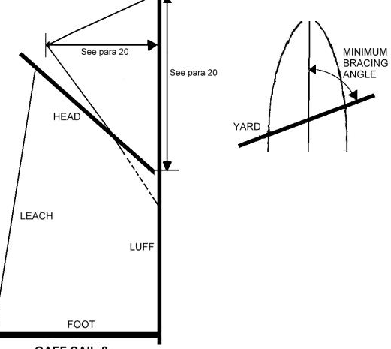
FORE &
АFТ LINE
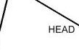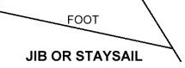
LEACH
LUFF

SQUARESAIL

QUADRILATERAL STAYSAIL
LEACH
FOOT
LUFF
LEA CH
LUFF
FOOT

CENTRE LINE

BERMUDAN SAIL

GAFF SAIL & GAFF TOPSAIL

MINIMUM BRACING ANGLE

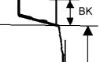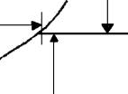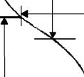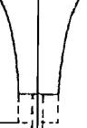
ВМАХ
1/4 ВМАХ
FMD
BWL
ом
DM+CD
- - ---'- 1 r-·
11
1 1 1 1
- '"- - -

SECTION АТ ВМАХ STATION

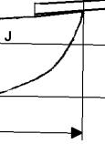
LDA
11
11

1 1
1 1
l(Y)
1 1
1 1
11
1 1
11
ВАО
BSPT
ВАD(У)
FFD 1/4 LWL
LWL

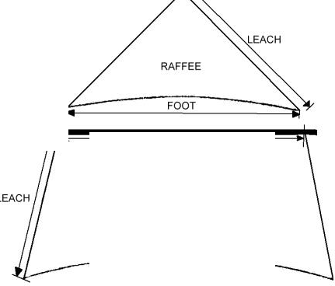
НЕА!>

Р.f,1120СТ2001

