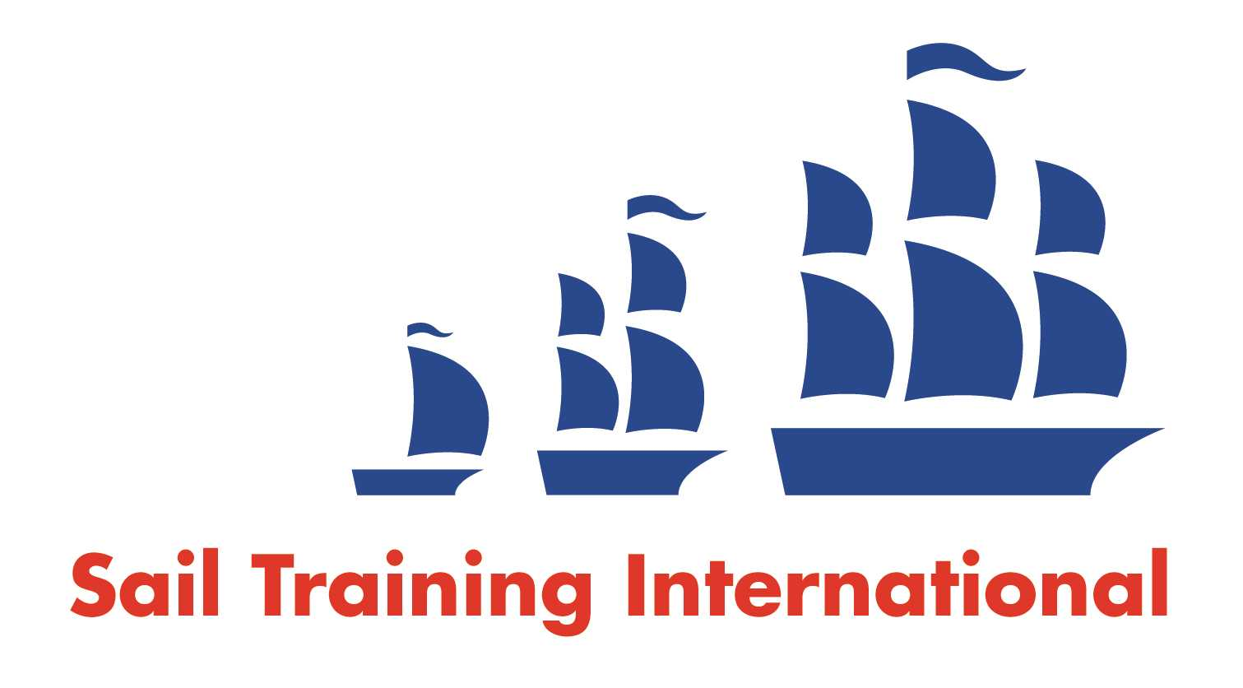
Sail Training International Positions Sought Submission Form

Editorial Policy

- This listing facility is open to any vessel operator or organisation involved in sail training.

- STI reserves the right not to publish a listing for any reason whatsoever.

- After completing the form, email to STI (office@sailtraininginternational.org) for editorial review prior to publishing on site. You can expect your advertisement to appear within 2-3 business days.

- Your listing will be automatically removed after three months unless you indicate an earlier date. To retain a listing beyond three months, please notify STI before the end of the three month period.

Date of Posting | 19th of April 2023
Name | Riemer Adam Kingma
Position Sought | Ship Doctor, Deckhand, Any
Location preference | Netherlands/Europe/Anywhere
Seasonal: July until December 2023 |  | Paid or voluntary
Description of Position Sought  (max 100 words) | Medical Doctor based in the Netherlands, main experience in emergency medicine and surgery.  Looking for a position to crew, preferably on a Tall Ship or large sailing vessel.  Able to help with nearly any task on board required. Enthusiastic, social.  Especially interested to join the Tall Ships Races.
Qualifications | Dutch MD Degree, several basic sailing qualifications (including International Certificate for Operators of Pleasure Craft)
Email | riemerkingma@gmail.com
Telephone | +31655164010


