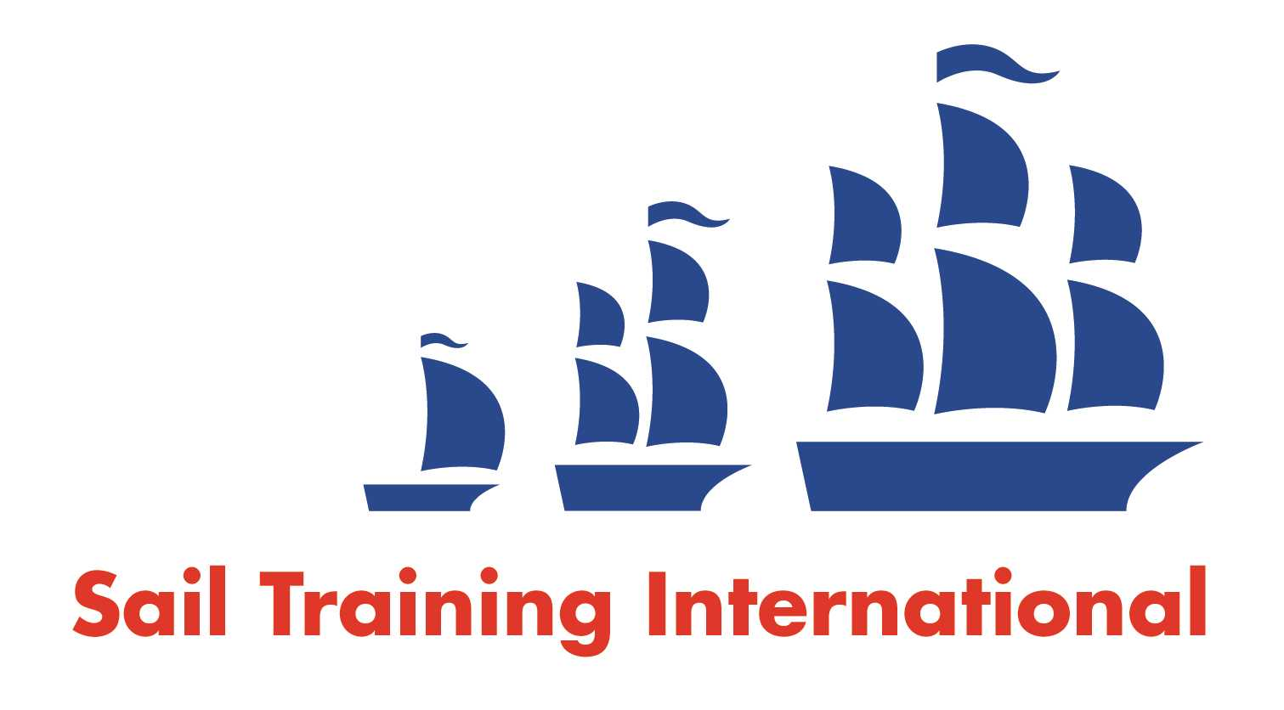
Sail Training International Paid/Volunteer Positions Submission Form

Editorial Policy

- This listing facility is free of charge but will only be accepted from sail training organisations and vessel operators that are members of their national sail training organisation or the Sail Training International Class A Tall Ships Forum.

- STI reserves the right not to publish a listing for any reason whatsoever.

- After completing the form, email to STI (office@sailtraininginternational.org) with copy to your National Sail Training Organisation for editorial review and approval prior to publishing on site.

Date of Posting | 01/11/2022
Name of Vessel | Ocean Spirit of Moray
Organisation Recruiting | Gordonstoun School
Name of Position | Watch Leader
Location of Position | Scotland West Coast
Position is |  |  | Seasonal | X
Remuneration | Paid  (delete as appropriate) | £15,000.00 p/a (pro rata for contract period)
Description of Position | Watch Leaders “Ocean Spirit of Moray”  (2023 Sailing Season – fixed term March - October)  Gordonstoun is seeking dynamic and self-motivated Sail Trainers to be part of the professional team aboard our 80-foot Sail Training Ketch Ocean Spirit of Moray for the 2023 season.  Candidates should hold RYA Day Skipper/Watch Leader certificate or above, and be able to demonstrate a track record of working in positions of responsibility on board Sail Training vessels over 20 meters Please visit www.gordonstoun.org.uk for more information.
Person to Contact | recruitment@gordonstoun.org.uk
Organisation’s website: | www.gordonstoun.org.uk
Email | recruitment@gordonstoun.org.uk
Telephone | 01343 837916.
Fax
Closing Date for applications | Until Filled

