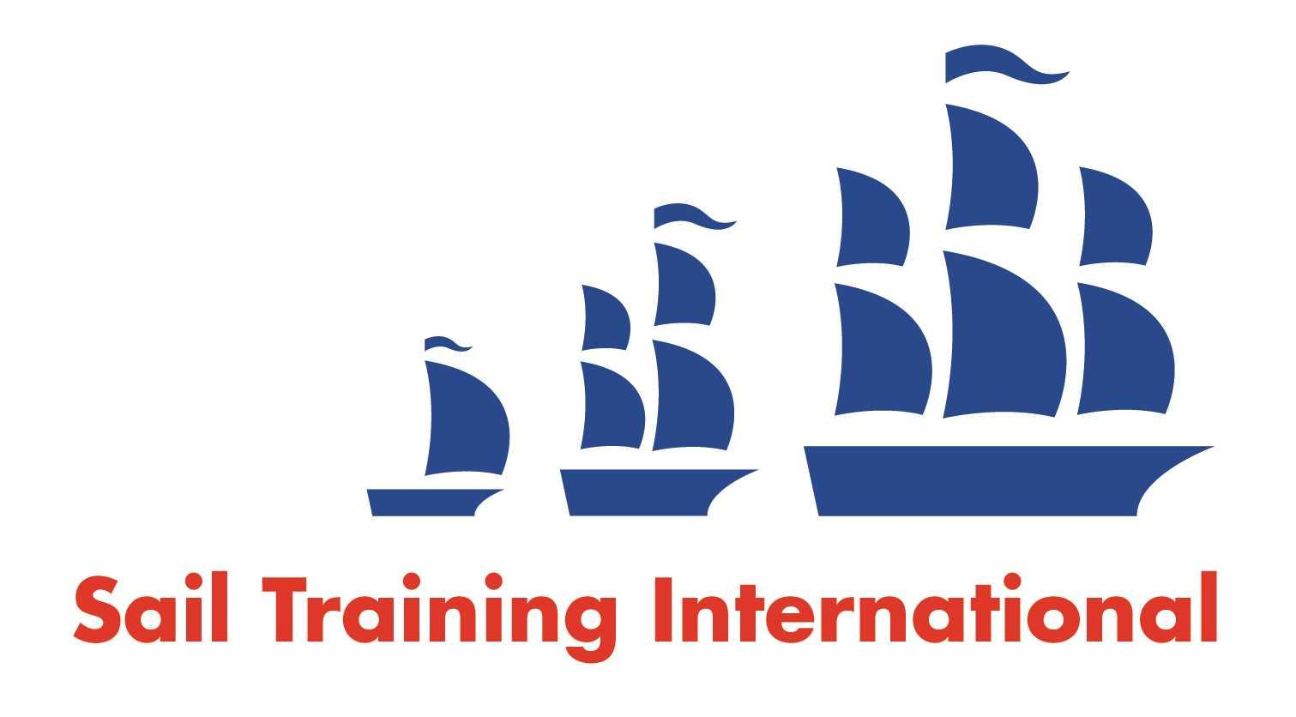
Sail Training International Positions Sought Submission Form

Editorial Policy

- This listing facility is open to any vessel operator or organisation involved in sail training.

- STI reserves the right not to publish a listing for any reason whatsoever.

- After completing the form, email to STI (office@sailtraininginternational.org) for editorial review prior to publishing on site. You can expect your advertisement to appear within 2-3 business days.

- Your listing will be automatically removed after three months unless you indicate an earlier date. To retain a listing beyond three months, please notify STI before the end of the three month period.

Date of Posting | December 1st 2020
Name | Leticia Taylor
Position Sought | deckhand/bosun/ cook
Location preference | world wide
Full Time / Seasonal |  | Paid
Description of Position Sought  (max 100 words) | I would like to work in youth sail training as deck hand, bosun or cook. I have worked as cooks mate on Gulden Lueew with class a float for 5 months, worked as a deck hand on bluenose 2, sailed with salts as trainee and volunteer ( cooks mate, bosuns mate, watch leader) for the past 11 summers. I participated in the Picton castle bosun school, and sailed with JST ( Lord Nelson) I would like to work on a tall ship looking for part time or seasonal around the world. Will be getting more certificates February 2021. I am a hard worker and eager to learn and teach. No job to dirty, I love building a community and being able to connect with trainees and crew on a deep level. I also volunteer for ships 2 shores a Canadian youth led program to promote tall ship sailing to youth in Canada.
Qualifications | ENG, STCW95, Picton castle bosun school
Email | Leticia.m.taylor@gmail.com
Telephone | 1(250)5377148

