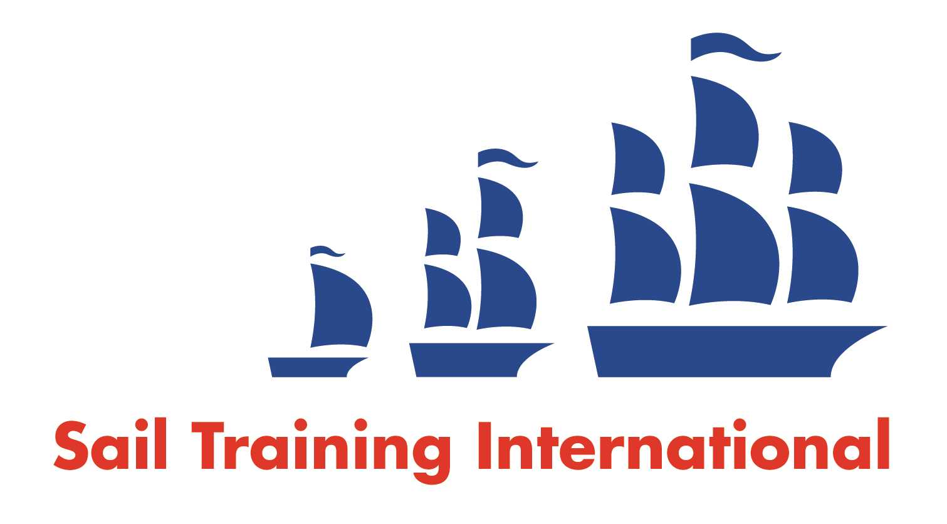
Sail Training International Paid/Volunteer Positions Submission Form

Editorial Policy

- This listing facility is free of charge but will only be accepted from sail training organisations and vessel operators that are members of their national sail training organisation or the Sail Training International Class A Tall Ships Forum.

- STI reserves the right not to publish a listing for any reason whatsoever.

- After completing the form, email to STI (office@sailtraininginternational.org) with copy to your National Sail Training Organisation for editorial review and approval prior to publishing on site.

Date of Posting | September 15, 2020
Name of Vessel | Black Dolphin
Organisation Recruiting | The Harbor School Ltd.
Name of Position | Captain
Location of Position | Hong Kong
Position is | Full Time | X | Seasonal
Remuneration | Paid | TBD
Description of Position | The successful applicant will be responsible for assisting in the development and delivery of an experiential, inquiry-based learning program making use of Black Dolphin as an outdoor classroom, managing scheduling of trips and one crew member, serving as captain on voyages in local waters from half day to several days in length, and directing a rigorous on-going maintenance and safety program for the yacht.
Person to Contact | Dr. Craig Blurton
Organisation’s website: | http://www.ths.edu.hk/the-black-dolphin
Email | cblurton@gmail.com
Telephone | 852-6776-4745
Fax | N/A
Closing Date for applications | December 10, 2020

