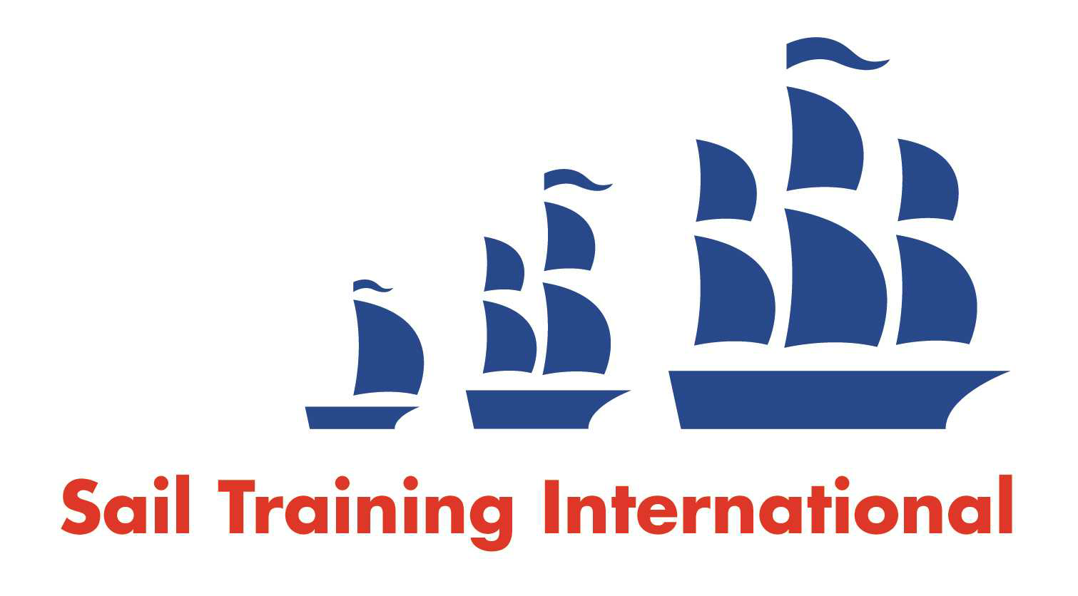
Sail Training International Positions Sought Submission Form

Editorial Policy

- This listing facility is open to any vessel operator or organisation involved in sail training.

- STI reserves the right not to publish a listing for any reason whatsoever.

- After completing the form, email to STI (office@sailtraininginternational.org) for editorial review prior to publishing on site. You can expect your advertisement to appear within 2-3 business days.

- Your listing will be automatically removed after three months unless you indicate an earlier date. To retain a listing beyond three months, please notify STI before the end of the three month period.

Date of Posting | 19/08/2020
Name | Wouter Kiekens
Position Sought | Deckhand
Location preference | Worldwide
Full Time / Seasonal  (delete as appropriate) |  | Paid / Voluntary  (delete as appropriate)
Description of Position Sought  (max 100 words) | Deckhand position to gain experience and climb up to officer and master.
Qualifications | Master comm yachting 500GT, Advanced firefighting, Medical first aid, GMDSS GOC, RYA Yacht Master Ocean...
Email | Wouterkiekens@hotmail.com
Telephone | +32476722715

